You Will Die at Twenty (12A)

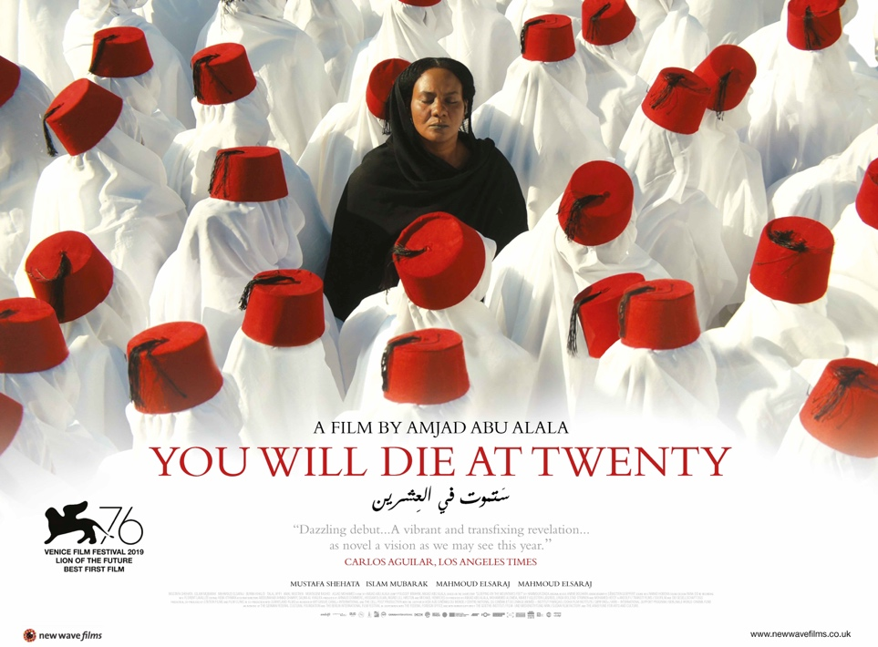

As Recommended by the FAN Young Consultants
& Students from the London College of Communication

Dir. Amjad Abu Alala|105 mins|Sudan, France, Egypt, Germany, Norway, Qatar|2019
Arabic with English subtitles

Distributor: New Wave
Bookings via Verve: colin@vervepics.com
Available: Friday 12th November
Platform: Theatrical and SVOD (Curzon Home Cinema and BFI Player)

Synopsis
Based on Sudanese writer Hammour Ziada’s short story, Sleeping at the Foot of the Mountain, You Will Die at Twenty follows the life of Muzamil (Mustafa Shehata) from birth until his 20th birthday. Muzamil’s religious Sufi village lies between the Blue and White Nile in Al Jazira state, Sudan, and at the boy’s naming ceremony, a sheik prophesizes that Muzamil will meet an early death at the age of twenty. Beholden to the grim fate, his mother, Sakina (Islam Mubarak), becomes overprotective and forbids his education or travelling, and his despairing father, Alnoor (Talal Afifi), leaves home for many years. The villagers taunt Muzamil, referring to him as “son of death”, and he becomes increasingly isolated, with only the opportunity to study the Koran. The quality of his life changes when he meets Suliman (Mahmoud Elsaraj), a Sudanese cinematographer, who imparts his passion for cinema and existential ideas with the curious teenager. A conflict grows within Muzamil between his traditional values and newfound modern aspirations. Will he have the time to act out his desires?

Awards

Winner – Best Debut Film – Venice Film Festival 2019
Winner – Best First Film, Best Screenplay, FIPRESCI Award - Carthage Film Festival 2019
Winner – Hamburg Producers Award – Hamburg Film Festival
Winner – Best Film – El Gouna Film Festival 2019

Social

Official website: www.newwavefilms.co.uk
Official Twitter: @NewWaveFilms
Official Facebook: @newwavefilmsuk
Official Instagram: @newwavefilmsuk
hashtag: #Youwilldieat20 #YouWillDieAtTwenty

Press

★★★★ "Sudan’s first Oscar entry... warmed by compassion and gorgeous dreamy imagery. ‘The film is a parable about the dangers of blind faith in religion and authority…there are some gorgeous images here, too."
Cath Clarke, THE GUARDIAN

★★★★★"Exploring concepts of mortality and morality in a number of intelligent and gripping ways… fantastic cinematography and sound design…great production work is bolstered further by a talented cast who deliver powerful and emotive performances… perfectly."
Umar Ali, THE UPCOMING

★★★★1/2 “Gorgeously crafted, melancholic exploration of what it means to live, what it means to die, and how the two intersect.
Joseph Thomasik, LOUD AND CLEAR

“…A modern parable where tradition and progression collide to produce an almost mystical drama...spins an intelligent and affecting yarn in complex hues.”

"Beautifully shot, Amjad Abu Alala’s film is assuredly done...It feels timeless in a way.
Rob Aldham, BACKSTREET MAFIA

"A folk tale turns existential in “You Will Die at Twenty,” the rapturous debut feature by the Sudanese filmmaker Amjad Abu Alala."
Devika Girish, The New York Times

Assets

Full information and listings

TRAILER:
YouTube - link or embed
Trailer download mp4
Download trailer ProRes

IMAGES:
Download photo set
Download 3 higher res photos tiff

POSTER:
Download quad poster - high res jpg

BBFC Guidance
Brief sexual threat, infrequent strong language

FAN Young Consultants
The FAN Young Consultants group is a 10 strong group of under 30 year olds working in Film Exhibition across the UK. Working with Film Hub London’s Young Audiences Manager Moira McVean, the group is recommending new release films that they believe will resonate particularly well with their peers and young people aged 16-30.
Previous titles supported by the group include Parasite, Portrait of a Lady on Fire, The Assistant, Days of the Bagnold Summer, Babyteeth, Socrates, Rocks, County Lines, Mogul Mowgli, Willy’s Wonderland, Sound of Metal, Last Man Standing, Night of the Kings, Limbo, Souad, Gagarine. Packs can be downloaded here

Feedback from students at the London College of Communications (BA Film & Screen Studies)
The students are part of the BA (Hons) Film and Screen Studies at London College of Communication, University of the Arts, London. They study the historical, theoretical, cultural, and critical analysis of film and screen, developing the next generation of filmmakers and influencers in the commissioning, distribution, curation and exhibition of film and screen.

- I really liked this film I’ve never seen any Sudanese cinema before so this was a great first experience. There were some moments where the music and cinematography were just gorgeous. Really enjoyed it. (Kareyni Davis)

- I liked it. It’s definitely very different from what I have seen before. I loved the opportunity to see a film on a culture so different from mine.

- I very much enjoyed the film, I thought the cinematography and sound design was incredibly beautiful. I thought the story was incredibly powerful and captivating. It perhaps would not have a super broad appeal because it's fairly slow, but I think it would appeal to cinephiles. However, I don't think the film would have the same impact outside of the cinema space.

- I thought the film was a beautiful look into a young man’s life, unsure of how to live it if there’s a quickly arriving end. I found the pacing rather slow but when getting used to it, it became very reflective. It had a narrative that I haven't seen before so I would be very interested in looking up the team that has made it to watch more of their work.

- I thought the film was engaging, frustrating, and touching. The performances were full of emotion. The story was beautifully told; the moral of the story was artistically communicated. A fascinating lesson on religion, family, and life. (Maya Adams)

- The film was beautifully shot, the colour theory was very prominent and at times vibrant.

- I enjoyed the film it was very authentic and a good insight on Sudanese culture and practice. It made me question does religion make you a good person? If we only do what’s seen as ‘the right thing’ (practising religion in this case) do we ever know what’s good and what’s bad? - we have no understanding of one without the other - this came to mind because regardless of how kind and religious the main character was he was still flawed as a result of the rape. Was he ever a good person? Is this because he never experienced good and bad for himself because he lived in fear of dying and doing the wrong thing?

- The Film was beautifully shot, especially the scenes where his younger self and him were present on screen together. This was an interesting way to look at grief and death and one’s own life. The intimate family dynamic was also interesting.

- The images in the film are really enjoyable to watch, including the settings, framing, and lighting. I like the way it was depicted with so many details that are related to the theme of death, as in the boy is used to listening to people’s heartbeats when they are sleeping.

- I really enjoyed the very personal and emotional story of the film and I think that this was really highlighted by the talented cinematography, music and acting. I also found its depiction of Sudanese culture to be very interesting as it is a culture that I am not used to seeing represented in film. (Sophie Gosling)

- I liked the film a lot for its honesty in depicting a young troubled life, I expected Muzamil to expand beyond his ‘so called’ fate and maybe leave his village in search of new beginnings. (Maya Anouman)

- Thoroughly enjoyed the film, as likely so for others, it’s the first Sudanese film I’ve seen and was a great introduction to the country’s industry. It covers topics that would interest those over 18, I’d say ages under wouldn’t be as interested as they’re more suited for ‘lighter’ entertainment. Definitely a good watch for older audiences. The cinematography and misé-en-scene was impressive throughout, the sound design and acting was nothing less than superb. (Renée LA)

Comparison/Complementary titles
Time of the Gypsies, Un Prophète, I am Not a Witch, Life of Pi, Cinema Paradiso, Night of the Kings, Bab’Aziz: The Prince That Contemplated His Soul

Themes
Death, religion, heartbreak, independence, family, coming of age, superstition, oppression, fear, denial, youth, childhood and freedom.

Key Selling Points

- Religious aspects are compelling
- The score is really good
- The dying at twenty
- Fact that it’s Sudanese
- The cinematography is stunning
- The sound design
- Culturally specific narrative (it’s unlike anything I’ve seen before)

Recommended age: 18-25

Marketing ideas

- Can you do a ticketing offer? Pay what you can model? 2 for 1 or group discount for up to 6?
- Think about which platforms you’re using to communicate with your audiences – the cinematography in this film is extraordinary so Instagram is the perfect place to pitch it to your young audiences.
- It’s the first feature to have been made in Sudan for 20 years and only the 7th to have come out of the country and is this year’s Oscar entry for Sudan. Cinemas were shuttered in Sudan for 30 years under the autocrat Omar al-Bashir who was finally ousted in April 2019 (whilst this film was being made). Muzamil has his first experience of cinema, watching old documentary and feature archive footage in the home of Sulaiman, a bed sheet serving as a makeshift screen. In this digital age there is a fascination with ‘real film’ stock. 16mm events are increasingly popular. Could you bring one in and project a short before the feature? Or recreate Muzamil’s experience with an exhibition in the foyer?
- Storytelling and magical realism are a huge part of the film. Do you have any local spoken word artists, poets or storytellers who could entertain the audience before a screening?
- Live music and themed food are a draw too. Could you collaborate with local artists/restaurants to create a special event? Alternatively, the soundtrack is available to buy on Amazon (see link below).
- Shrines to Sufism are present in the waters around Muzamil’s village and of course, the ‘curse’ of the Sufi determines the path of Muzamil’s life. Do you have anyone in your region that you could invite to introduce the film and to talk about Sufism? There is a short introduction to Sufism video included in the links below.

Recent audience data research conducted by Google suggests that more than ever, young people are interested in researching the background of the content they’re watching. This film warrants and deserves reading around. Here are some great articles to point audiences (and yourself) to:

Interesting Articles/Videos/contacts:

- New York African Film Fest 2020 Interview with Director Amjad Abu Alala (recorded Q&A)
- Director Interview- Thrive Global
- Director Interview - Variety
- Director Interview - NPR
- Soundtrack – You Will Die At Twenty
- Gulf News on the reopening of cinemas in Sudan following the fall of Bashir (April 2019)
- Sula Douglas Folkes – Magical Realism in African Cinema
- Introduction to Sufism

