Sick of Myself (15)

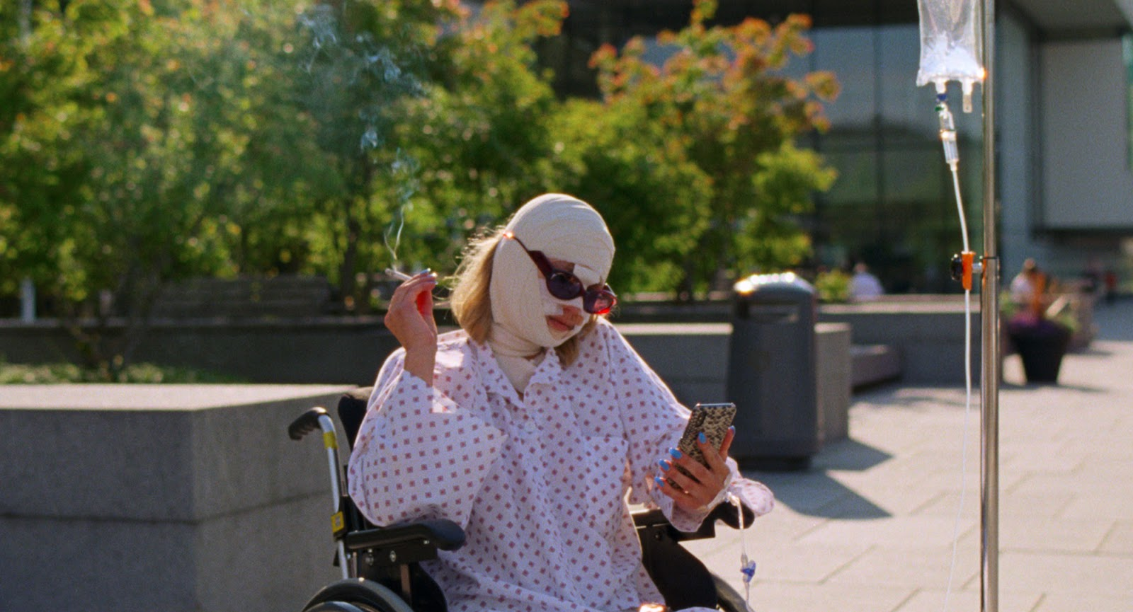

As Recommended by the FAN Young Consultants

Dir. Kristoffer Borgli|Nor/Swe/Den/Fr |2022| 97 mins

Distributor: Modern Films
Bookings: anna@modernfilms.com & rossella@modernfilms.com
Available: 21st April 2023
Platform: Theatrical (available virtually from 5th June)
DCP available with SDH

Cast: Kristine Kujath Thorp (Ninja Baby), Eirik Sæther, Fanny Vaager
Language: Norwegian/Swedish

BBFC guidance: very strong language, strong bloody images, sex, drug misuse, self-harm

Synopsis
Increasingly overshadowed by her boyfriend’s recent rise to fame as a contemporary artist creating sculptures from stolen furniture, Signe hatches a vicious plan to reclaim her rightfully deserved attention within the milieu of Oslo’s cultural scene.

2022 Cannes Film Festival
Official Selection
2022 BFI London Film Festival
Official Selection
2022 Cambridge Film Festival
Official Selection

2022 Leeds Film Festival
Official Selection
2023 Dublin International Film Festival
Dublin Film Critics Circle Award, Best Actress

Social

Twitter & Instagram @modernfilmsent
Facebook @modernfilms
Official website: https://www.modernfilms.com/sickofmyself
Official hashtag: #Sickofmyself
Social handles:

Director Kristoffer Borgli @kristogger

Press Quotes

“The real Worst Person in the World will ruin your life with a smile” IndieWire

“An unforgettable film, one of the festival’s best, and deliciously infuriating” Cineuropa

“Horribly, shamefully, hilariously relatable” ★★★★ Loud and Clear

“A squirm-inducing wonder” Deadline

“A whip-smart black comedy out of Norway that shines a damning light on society’s self-obsession” ★★★★★ Time Out

Fellow Film Directors, Writers and Actors Quotes

Bret Easton Ellis
“Hilarious and horrifying. One of the first movies to really sum up the hideous moment we live in and what it does to people.”

John Waters
“Pretty fucked up! No, it’s not ‘Female Trouble,’ but it’s just as nuts.”

Michael Cera
“I laughed a lot, then afterwards was reflective and standoffish for a short while.”

Ari Aster
“The work of a demonic parodist with chutzpah and judgement to spare. As misanthropic and committed to its soul-sick worldview as any black comedy. Grotesque, deeply mean-spirited, and heroically unwilling to waver from the joke.”

Assets

Key stills - here
Press kit - here
Directors’ photo - here
Poster - here
Trailer - here
Social media assets - here

FAN Young Consultants Feedback
The FAN Young Consultants group is a 10 strong group of under 30 year olds working in Film Exhibition across the UK. Working with Film Hub London’s Young Audiences Manager Moira McVean, the group is recommending new release films that they believe will resonate particularly well with their peers and young people aged 16-30.
Previous titles supported by the group include Parasite, Portrait of a Lady on Fire, The Assistant, Days of the Bagnold Summer, Babyteeth, Socrates, Rocks, County Lines, Mogul Mowgli, Willy’s Wonderland, Sound of Metal, Last Man Standing, Night of the Kings, Limbo, Souad, Gagarine You Will Die at Twenty, Petite Maman, Bad Luck Banging: or Loony Porn, Boiling Point, Belle, Flee, Ali & Ava, Happening, The Worst Person in the World, All My Friends Hate Me, Pleasure, The Feast, Queen of Glory, Off the Rails, Triangle of Sadness, Neptune Frost, All the Beauty and the Bloodshed, Blue Jean, Subject. Packs can be downloaded here

Alex
If you loved The Worst Person In The World like I did then you should be eager to seek this film out. Sick of Myself provides a character that might actually be the embodiment of the ‘worst person’… a terrible, and sick one at the very least. Sick of Myself is a darkly humorous affair, often absurd, and frequently uncomfortable. The film follows Signe and Thomas, an unhealthy couple made up of a narcissism and the need for attention. When Thomas finds success as an artist, Signe spirals into compulsive lying as she tries to find fame for herself, which comes in the most unexpected, and sickening of ways. The film picks on Signe’s delusions, her warped sense of reality and self-awareness though some very surreal moments, including one that gives Daniels Anderson Lie a terrific cameo that sets the tone for the rest of the film. There are a lot of interesting moments that explore Signe’s self-absorbed personality alongside her intrusive anxieties. It’s a tough watch at times, with body-horror, insensitivities that provide very little pay-off, and an irredeemable character front and centre… but it’s not without engrossing thought and originality.

Colette
Kind of like if The Worst Person in the World met Todd Haynes' Safe and then John Carpenter got involved for good measure… I really loved this, it’s fun and nasty. It feels like a great antidote to overly sincere or soft filmmaking, and isn't afraid to really lean into the body horror madness too. I loved the sharp, cynical, and genuinely funny takedowns of contemporary narcissism, and a lot of its strengths lay in the little moments. This could do really well with 16-30 year olds particularly because it feels really unapologetic in its nastiness, which I think will be a welcome change.

Feedback from students at the London College of Communications (BA Film & Screen Studies)
The students are part of the BA (Hons) Film and Screen Studies at London College of Communication, University of the Arts, London. They study the historical, theoretical, cultural, and critical analysis of film and screen, developing the next generation of filmmakers and influencers in the commissioning, distribution, curation and exhibition of film and screen.

Kareyni
“I absolutely loved it. It was really funny how this white woman craved attention so much to the point of damaging herself all while thinking she’s the greatest victim in the world.”

White
“My favourite film in 2022!!!!! We can see the problem of modern art: getting attention for being nothing, and they still think they’re talented.”

Dami
“I honestly found the film hilarious it’s nothing like what I’ve seen before, the lengths the main character goes to get attention is hilarious.”

Chloe
“Very original way to express today's society's obsession with attention seeking without the main focus being social media.”

Erin
“I really enjoyed the film, i thought the acting was incredible and the storyline interesting. It doesn’t feel like any other film that I have seen before.”

Sophie
“I enjoyed the films very dark style of comedy and clever writing. The escalating deception created a strong sense of tension throughout the whole film.”

Grace
“A unique genre that I can’t put my finger on. Almost like a psychological thriller with horror tones. I really enjoyed it as it experiential and shamefully relatable in an exaggerated tone. It’s something I’ve never seen before.”

Chloe
“It’s a very curious movie for me. Love the editing. The story is exaggerated and ironic which I find attractive.”

Isabella
“I thought the story was very intriguing, as it definitely portrayed how far people can go for attention in today’s society. I feel like a lot of people can definitely relate to many situations in the film (although maybe not as extremely), such as relationships expectations and society’s fetishization of pain.”

Lauren
“I really loved Sick of Myself! It was a great mix of dark and witty and kept me engaged the entire time. The performance of the main actress was really great — you hate her and love her at the same time. I would definitely recommend this for people in the 16–30 age range.”

Comparison/Complementary titles:
Munchausen; Phantom Thread, Requiem for a Dream, Raw, The Piano Teacher, Swallow, The Square, One Flew Over the Cuckoo’s Nest, The Square, Heathers

Themes
Comedy, drama, romance, lies, gore, validation, insanity, self-harm, obsession, loneliness, modern life, narcissism, self-destruction, jealousy, pretentious art culture, fame

Recommended age
Sweet spot of 19-25

Marketing ideas

- Can you do a ticketing offer? Pay what you can model? 2 for 1 or group discount for up to 6?
- Think about which platforms you’re using to communicate with your audiences (Instagram and Twitter recommended for this title and target age group)
- Set up a post screening informal ‘wine/beer & chat’ session
- Can you invite a local comedian to do a stand up session before or after the film? Or an open mic night?
- Could you come up with a publicity stunt (similar to the one in the film but legal?!)
- Challenge the audience (perhaps through your social media interaction) to describe how far they’d go for attention.
- From the comments above you’ll see that students/young consultants loved the film but found it difficult to pigeonhole which made them love it more for fresh and original perspective. They all suggested having someone introduce the film and talk about its genre bending themes and presentation would be great.
- The complementary films suggested are wide ranging. Could you programme a ‘gross out’ double bill or a contextualised mini season?
- Stage a magazine photo cover shoot in your foyer using polaroids
- Commission a local blogger to write about the themes of the film for your audience

Interesting Articles/Videos/contacts:

- Interview with Kristine Kujath Thorp – The Upcoming
- Interview with Kristoffer Borgli – The Upcoming
- Mubi’s profile of the film with audience comments and critics reviews

