Robot Dreams (PG)

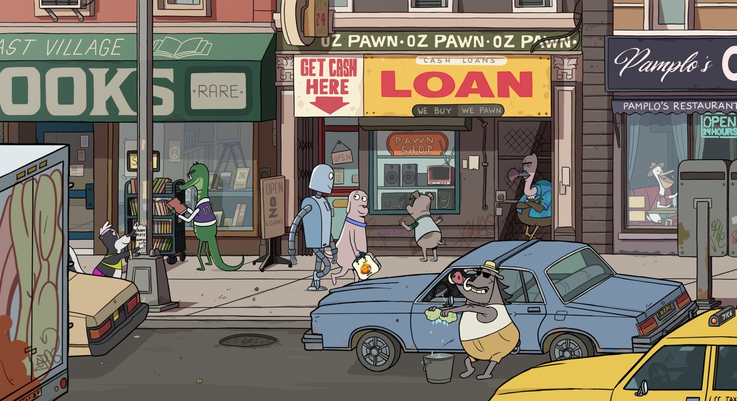

Dir. Pablo Berger |Spain/France |2023| 102 mins

Distributor: Curzon
Bookings: Jamie.Mendonca@curzon.com
Available: 22 March
Platform: Theatrical/Curzon Home Cinema
Recorded Director introduction (15 mins): Available from Curzon

Language: dialogue free, HOH subs available

BBFC guidance: mild rude humour

Synopsis
A heart-swelling, hand-drawn delight that invites audiences of all ages to explore love and loss through its tender portrait of a new friendship. Part of the Official Selection of the 2023 Cannes Film Festival, Oscar-nominated Robot Dreams is the first animated film from Pablo Berger (Blancanieves).

Dog is lonely. He spends a lot of time by himself, whiling away long evenings in his Manhattan studio apartment, eating microwave meals for one in front of the TV. Tired of his solitary existence, he decides to purchase a friend. When his order arrives, he builds Robot, a fun-loving, happy-go-lucky companion to keep him company. Dog and Robot spend an idyllic day together – frolicking through the city to the joyful melody of Earth, Wind & Fire’s ‘September’ – ending up at Coney Island to enjoy the fun. But they are soon separated on the beach. Dog, devastated at the loss of his friend, does everything in his power to get Robot back.

Set in the 1980s, vivified by a poppy soundtrack and a strong affinity for cinema history, Robot Dreams is a deeply felt, bittersweet buddy comedy that embraces ambiguity and the uncertainty of life’s path.

Cutdown:
A bittersweet buddy comedy, Robot Dreams follows Dog, who is lonely, whiling away long evenings in his Manhattan studio apartment. Tired of his solitary life, he decides to purchase a friend, Robot, a fun-loving companion. After an idyllic day on the beach, they soon become separated. Devastated at the loss of his friend, Dog does everything in his power to get Robot back.

Socials

Official website:
Official X: @curzonfilm
Official Facebook: https://www.facebook.com/CurzonFilm
Official Instagram: @curzonfilm
Official hashtag: #RobotDreams
Social handles:
Sara.Varon (Instagram)

Press Quotes

The Telegraph - Robbie Collin ★★★★★
"Overflowing with handcrafted charm... witty, gorgeous and profound."
Sight & Sound - Alex Dudok De Wit
"Robot Dreams is a story about how swiftly and lastingly a bond of affection can mark a life"

Time Out - Phil de Semlyen ★★★★
"delightfully quirky, funny and moving"
La Nación - Leonardo D'Esposito
"If the outcome is completely satisfactory, it is also complex: an adult will experience it with a lump in their throat; a child, with the naturalness of discovering that time heals sadness and affirms happiness."

Assets
- Trailer
- Stills
- Socials
- Press Notes
- Poster
- Official synopsis
- Activity Sheet

Comparison/Complementary titles:
Ron’s Gone Wrong, Big Hero 6, Wall-E, Ernest & Celestine - for older audiences think My Life as a Courgette, The Red Turtle, The Breadwinner

Themes
Friendship, loneliness, moving on/time heals, music, New York City in the ‘80s, hand-drawn 2D animation, graphic novels

Recommended age: 6+ Sweet spot: 8+

Parental guidance from Common Sense Media
“Parents need to know that Robot Dreams is a dialogue-free animated film about the joy and fragility of friendship. It's based on Sara Varon's graphic novel about the relationship between a dog and the robot he builds. Comedic and poignant, it has very little iffy content -- just one brief comedic scene where characters flip their middle fingers at someone. But the movie's kid-friendly cartoon artwork belies the emotion of the story's circumstances. Robot's parts rust on the beach, stranding him alone in the sand for months: He's paralyzed, escaping his situation through wishful imaginative scenarios and memories of his best friend, Dog (who fills the void by keeping active with new friends). Robot knows Dog can't get to him, but viewers may still experience Robot's situation as abandonment. This, and the brutish treatment he receives from those who come across him and think he's scrap, is likely to send your compassion into overdrive (and possibly spark tears). Just know that (spoiler alert!) an unpredictable but happy ending is on the way -- one that's a great conversation starter for tweens.

Educational Value
The film is a social-emotional demonstration of the fact that some friendships aren't forever, and that's OK.

Positive Messages
Having a friend is a joyful experience, and friends can grow from the time they spend together. Sometimes even close friends drift away, but new friendships will be made, and that can lead to new experiences. Themes of friendship and loneliness, and Robot's story is likely to inspire compassion.

Positive Role Models
Dog and Robot have a close friendship -- they get each other. When Robot is stuck on the beach, Dog tries everything he can to get him out. When he's finally able to legally free Robot, he returns. Still, some viewers might think Dog could have done more.

Violence & Scariness
Robot gets stuck and can't be retrieved for months. While circumstances, rather than a lack of trying, prevent his rescue, it emotionally plays like abandonment. Parts of Robot's body are removed and thrown around, which viewers may perceive as cruelty.

Products & Purchases
Brands are everywhere to help establish character and life in 1980s New York, including Cheetos, Froot Loops, Coke, Vespa, White Castle, Jelly Belly, and Ginsu knives.”

Marketing ideas

- Can you do a family ticketing offer? Or pay what you can model?
- Think about which platforms you’re using to communicate with your audiences’ families are still reliant on Facebook for finding out about special events or targeted activities
- Run the recorded intro before each screening
- Run a pre (or post) screening film related activity – see suggestions below
- Print and share the activity sheet and have colouring pens available in the foyer for the children to use.
- The film’s soundtrack is really upbeat and vibrant. It’s available via Apple Music and Amazon and would be great to play in the foyer to get everyone in the mood!

Pre (or post) screening activity ideas

- Storyboarding – As you’ll be able to read in the introduction of the press notes (see Assets above) Pablo Berger is a very precise filmmaker. He storyboards everything that he shoots and he shoots everything he storyboards. Introduce storyboarding to your young audience (and parents/carers) and invite them to do a short storyboard for a fun memory – might be a holiday or a party or similar.
Download a free printable template
- Design your own robot friend
Printable robot template; Robot bits and bobs
- If you were an animal, what animal would you be and why?
Animal craft ideas
- Animate your character with a flip book!
Youtuber Ryan’s tutorial; Andymation flip book tutorial
- 80’s disco
Teach the children a simple dance routine to Earth, Wind and Fire’s September that features throughout the film. If you don’t have the space you could just teach the arm movements in their cinema seats so that they can join in at the relevant time!

Post Screening Discussion suggested questions for Tweens (Common Sense Media)

- Talk about the saying, "If you love someone, let them go." What does that mean? How does it play out in Robot Dreams?
- What does perseverance mean and why do you think it’s an important trait for characters to have? Do you think Dog did everything he could to rescue Robot? Was there anything else he could do?
- Dog decides that he needs a companion and takes action to get one. What are some ways you can think of to meet people and make friends?

Interesting Articles

- https://www.awn.com/animationworld/pablo-berger-talks-his-oscar-nominated-robot-dreams
- Youtube video of Pablo Berger talking about how he expanded Sara Varon’s Graphic novel
- Sara Varon’s website https://chickenopolis.com
- 04.03.24 SIGHT AND SOUND (1).pdf

