PORTRAIT OF A LADY ON FIRE
As recommended by the BFI FAN Young Consultants

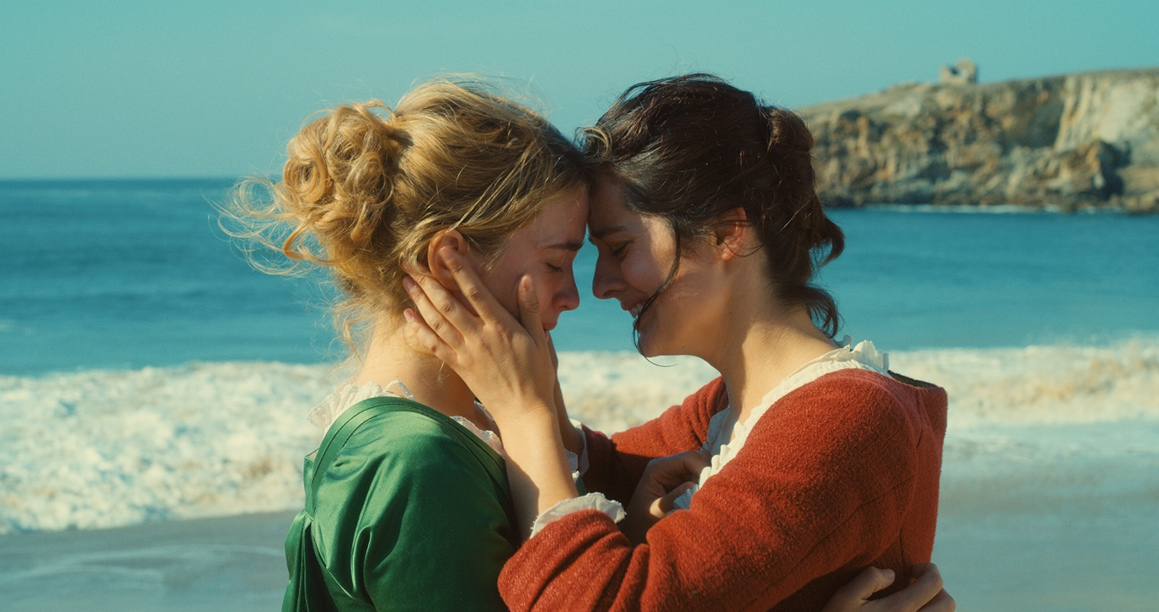

Specification details:
Portrait of a Lady on Fire
Dir. Céline Sciamma | Cert 15 | 122 mins |2019

Distributor: Curzon Artificial Eye
Bookings through Curzon: jamie.mendonca@curzon.com
Available: 28 February 2020

Official Synopsis:

Romance and art entwine in PORTRAIT OF A LADY ON FIRE, a sumptuous new masterpiece from Céline Sciamma (TOMBOY, GIRLHOOD).

Set in late 18th century France, painter Marianne (Noémie Merlant) is commissioned by an affluent countess to paint the wedding portrait of her sheltered but headstrong daughter Héloïse (Adèle Haenel), in the hope it will find her a wealthy husband.

While posing as her hired companion, Marianne is instructed to complete the portrait in secret, observing Héloïse by day and painting her by night. However, as the two women grow closer, their intimacy and attraction begins to blossom, paving the way for a simmering, star-crossed romance.

A heartbreaking period piece told with a distinctly modern feminist energy, PORTRAIT OF A LADY ON FIRE is the first female-directed film to win the Queer Palm at the Cannes Film Festival, where it also won the Best Screenplay award.

FAN Young Consultants feedback
The FAN Young Consultants are a 21 strong group of under 30 year olds working in Film Exhibition across the UK. Working with Film Hub London’s Young Audience lead Moira McVean, moira.mcvean@filmlondon.org.uk the group will be recommending new release films that they believe will resonate particularly well with their peers and young people aged 16-30.

Consultants reviews (please contact Moira.McVean@filmlondon.org.uk if you would like to reference any of these):

“Just an absolutely stunning piece of cinema. Subtle but totally captivating. Wonderful performances - Sciamma's best film yet.”

“Beautiful and stunning film. A piece of cinema solely about the concept of looking and gaze. Both performances kept me engaged for the entire film.”

“Beautiful and beguiling. I found the nuanced style and quiet moments in Portrait Of A Lady On Fire refreshing. This film succeeds in captivating an audience through subtleness and enticing performances, rather than garishness or gratuity.”

“Sublime, both in its examination of how it feels to look and be looked at, in its sensuous and delicate romance, in its (appropriately) painterly photography. So devastating to watch that I can't possibly imagine how it feels to make a film like this with your ex in one of the lead roles. Also has the best Vivaldi music cue this side of John Wick, what romantic drama can boast that?“

“Céline Sciamma wrote Portrait de la jeune fille en feu for Adele Haenel (Héloïse) when they were in a relationship. That explains the genuine tenderness of the film. I think Portrait.. is a subtle love declaration to all women and a call to sisterhood. Unlike Kechiche’s Blue is the warmest colour, the sex scenes are only suggested, not rudely exposed and caricatured, and I didn’t miss them. The intensity and intimacy of the relationship between the two characters are sufficient. The photography is breath-taking. Overall, I think Portrait de la jeune fille en feu is or will be important in cinema’s history: a film without men, a love story without objectification or domination. In France, the film is already becoming cult in the lesbian community and “page 28” is the new trend tattoo and a rallying sign.”

“Restrained, rich drama. Painfully believable and genuinely intimate - I sometimes feel that love scenes in queer centred films can be exploitative but it is clear the director is part of the community she is representing - perfectly capturing memory, loss, regret, desire. I really loved this film!”

“A truly gripping film that beautifully showcases the fragility that can come from romantic entanglements. Sciamma's portrayal of blossoming queer romance strikes at the heart of anyone who has ever felt longing.”

“Not a second is wasted in Céline Sciamma's latest arthouse masterpiece, Portrait of a Lady on Fire. There is beauty not only within the films museum-worthy cinematography but in the gentle chemistry between our two lead characters: Marianne, a female painter, and Héloïse, a somewhat mysterious and reluctant bride to be. On an isolated island in 18th Century France, Marianne is commissioned to paint Héloïse's wedding portrait but must do so in secret, observing her by day to paint her at night. Every moment is thoughtful about these characters, from the way they move and gently look at each other, to the soft, stirring conversations between them. An intimate slow burning romance ignites and you can truly feel the love between them grow in their few days of freedom together in solitude. The story is a reflection from what she is usually allowed to paint, to who she may love, and ultimately where both their lives must head; leading to some haunting visions. Her fleeting escape from all of this, sticks with the pair forever, delivering a beautifully chilling crescendo ending. Like Marianne quietly observing Héloïse, the more you watch this film the more you'll fall in love it.”

Target Audience(s):
19-30 year olds
LGBTQ cinema
French cinema
Arthouse cinema

Key themes:
Love/forbidden love
Identity
Gender
Equality
Sexuality
Art
Class

Event/marketing ideas from the Young Consultants:

- If you’re based in a mutli-arts venue or have an exhibition/education space, think about the potential to create a cinema ticket/art class deal. Think about inviting university lecturers/college tutors to discuss the themes raised in the film post screening.
- Think about a cheaper ticket deal for 16-25 year olds and promote it alongside the film
- If you have a local LGBTQ group or organisation, partner with them to promote the film/intro the film/host Q&As
- Preview screenings have significantly attracted under 26 year-olds so build on this momentum by connecting with the existing marketing campaign and messaging (see below).
- Is there a local French teacher/lecturer who could give a presentation on the work of Céline Sciamma, could they encourage their students to attend?
- Consider programming a Céline Sciamma retrospective and opening the season with an introduction to her work.
- Consider connecting with local art groups, galleries or student societies and hosting a life drawing class at your venue (or theirs).
- In terms of connecting with queer organisations/events and life drawing classes – here’s an example of a group
- Consider creating your own poster/assets for the film with a local artist

Official UK Assets:
Curzon created an illustrated teaser poster (designed by renowned poster designer Tony Stella) which was printed on a very limited and exclusive run and has since run out - but you can still share it online - you can find it here.

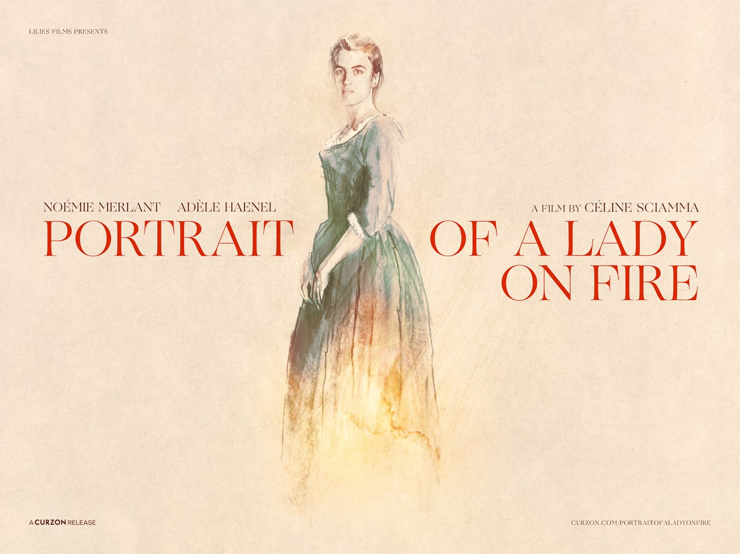

The official trailer is also available on Curzon’s YouTube channel here, and you can also download it here to share on your social channels, as well as play on any available in-venue plasma screens.

Official Digital Assets:
In this shared asset drive you'll also be able to find the below:

❤️ Digital quad & one sheet poster artwork
❤️ 30sec Preroll mp4 (in 16x9, 4:5 and 1x1)
❤️ GIFs / looped mp4 shareables
❤️ Square review cards & videos
❤️ Facebook (static and video) and Twitter covers
❤️ Collected best use review quotes
❤️ Official stills

Film critic reviews
Above is a selection of the best press quotes. To reach a younger audience, think about focusing on the female reviewers over the male ones. If you’d like to use one (or part of) the Young Consultants reviews above, please contact Moira.McVean@filmlondon.org.uk in the first instance.

Be sure to also follow the film’s official social media channels as well:

Official UK site: https://www.curzonartificialeye.com/portrait-of-a-lady-on-fire/

Twitter
@ArtificialEye

Instagram
@ArtificialEyeFilm

Facebook
@CurzonArtificialEye

Hashtags:
#PortraitofaLadyonFire
#PortraitMovie
#CélineSciamma
#AdèleHaenel
#NoémieMerland
#LGBT
#LGBTQ
#QueerFilm
#LGBTHM2020 (LGBTHM runs throughout February in the UK)
#WomenInFilm
#PortraitsofResistance

Search for ‘Page 28 Portrait’ to find the references to ‘page 28’ mentioned in the Young Consultants feedback above.

Additional campaign and marketing ideas

- Price: If you have a young person/student ticket offer, why not promote it alongside Portrait of a Lady on Fire
- Event: Think about hosting an International Women’s Day screening (8th March) as the film is ‘triple-F-rated’ which means the film is directed by a woman, written by a woman and stars women in significant roles on screen. To find out more about the ‘F-rating’ see here http://f-rated.org/about/
- Collaboration: As the film has such a high ‘F-rating’ think about collaborating with Birds’ Eye Veiw’s ‘Reclaim the Frame’ programme https://www.birds-eye-view.co.uk/influencers/

