PARASITE
As recommended by the BFI FAN Young Consultants

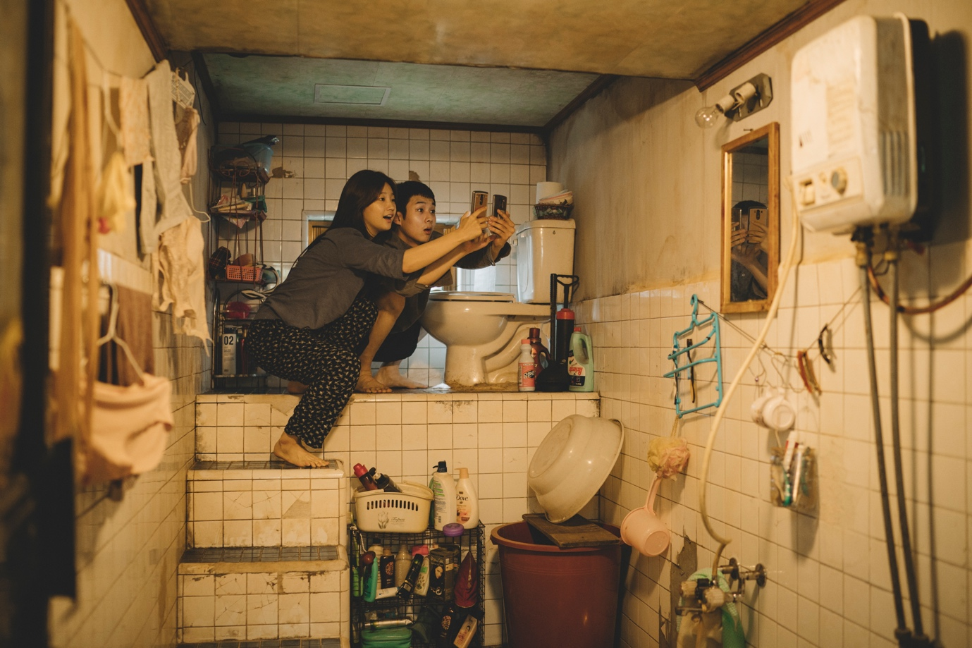

Specification details:
Parasite
Dir. Bong Joon Ho | Cert 15 | 132 mins |2019

Distributor: Curzon Artificial Eye
Bookings through Studio Canal: Gareth.HAWORTH@studiocanal.com; Natalie.Ralph@studiocanal.com; Kashif.SHIRAZI@studiocanal.com
Available: 7 February 2020

Official Synopsis:

The Kim family are close. All four live in a tiny basement flat and all four are unemployed. But when the son, Ki-woo, is recommended by his friend to take a well-paid tutoring job, hopes of a regular income blossom on the horizon. There’s only one small issue — he’s not a qualified teacher and has to fake it. Carrying the expectations of all his family, Ki-woo heads to the extravagant Park family home for an interview and after securing the job discovers they also need an art tutor for their son, something he thinks his sister could pretend to do… if they don’t know she’s his sister. Soon the whole family has infiltrated the Park home but as their deception unravels events begin to get increasingly out of hand in ways you simply cannot imagine.
Winner of the Palme d’Or, Bong Joon-ho reminds us that he is one of the world’s most exciting, talented and entertaining directors with the hilarious, scathing, thrilling and utterly unique Parasite.

FAN Young Consultants feedback
The FAN Young Consultants are a 21 strong group of under 30 year olds working in Film Exhibition across the UK. Working with Film Hub London’s Young Audience lead Moira McVean, moira.mcvean@filmlondon.org.uk the group will be recommending new release films that they believe will resonate particularly well with their peers and young people aged 16-30.

The first title they’d like to champion for 2020 is Parasite and here is some of the group’s thoughts on the film:

‘Absolutely brilliant. Sharp, witty, clever - beautifully shot, great score.
A fresh and wonderfully scathing portrayal of class division, that while being
entertaining brings home a heavy message.’
‘This film has totally stayed with me. It captures the zeitgeist right now of growing economic inequality, and its impact on society. The gap between rich and poor – a pattern repeated worldwide – impacts on health, life expectancy, job opportunities – all of which are depicted sharply (and with such a unique style) in this film.’
‘Really think this film have the same commercial impact as Get Out, Saw, Sixth Sense, Joker (in debate factor). This film translates and leaves you with themes and discussions surrounding class that you can take and debate with friends or even in a panel / school education environment. This film marks a significant moment in the establishment of Korean cinema.’
‘Arguably the best film I saw last year. Incredibly well made, very funny in the right places, amazingly acted. The conversations about class are something that isn't really occurring in other national cinemas. The film has that quality where you just want to go and tell everybody about it the minute you walk out of the room.’
‘An OUTSTANDING multi-genre thriller that has been expertly woven; its tonal leaps keep you at the edge of your seat. It's satire of the class-divide, a universal theme, is sharp. Its characters are easy to understand, their struggles and uncertainties in life, health and work are themes that won't be foreign to any audience. Parasite is a fun, thought-provoking masterpiece that thoroughly gripped me from start to finish, asserting itself as my favourite film of 2019 (and perhaps the decade).
‘Gorgeously short with a compelling narrative. Parasite was gripping throughout; its unpredictability was perhaps the quality I enjoyed most. The plot was imaginative and extreme, yet the themes presented were thoroughly rooted in reality. The film is therefore a great catalyst for conversation that people will be keen to talk about.’
‘At times unnerving, but unwaveringly endearing, film which cuts through any misconceptions that non-English language cinema is inaccessible. With themes around class which transcend geographical boundaries, Parasite is an urgent and engaging narrative of inequality.’

Key themes:
Family
Inequality/class
Food

Event/marketing ideas from the Young Consultants

- Invite speakers from local educational institutions/charities to lead panels/post screening discussions about the theme of inequality/class linked to current affairs i.e. global protests around inequality in Chile
- Link with Korean organisations in your area or make contact with the Korean Cultural Centre in London for speaker contacts/suggestions (see links below). Food is a key element of the film (particularly peaches!), are there Korean restaurants you could partner with? Connect the film with Korean culture more generally- see twitter hastag #asianstyle for ideas. K-Pop is huge online and has a big UK following.
- Create memes that riff on the idea of inequality and the other themes of the film -
See this tweet from the QFT for inspiration.
- Avoid the usual awards buzz and tap into the #bonghive (see more hashtag suggestions below
- Emphasise that this film is fun and playful and humorous but that it still packs a punch

Official UK Assets:
https://www.curzonartificialeye.com/parasite/
https://www.parasitemovie.co.uk/

Official Digital Assets:
https://drive.google.com/drive/folders/1YwmHZSS9mU8ub_7JCAOfEyeI2XUPdUD1

The alternative artwork such as the below poster image can also be found in the assets folder which Curzon Artificial Eye hope will speak more directly to younger audiences. Little White Lies launched the new artwork and their tweet has since gone viral LWL tweet. Feel free to retweet this tweet or to create your own social media posts using the assets.

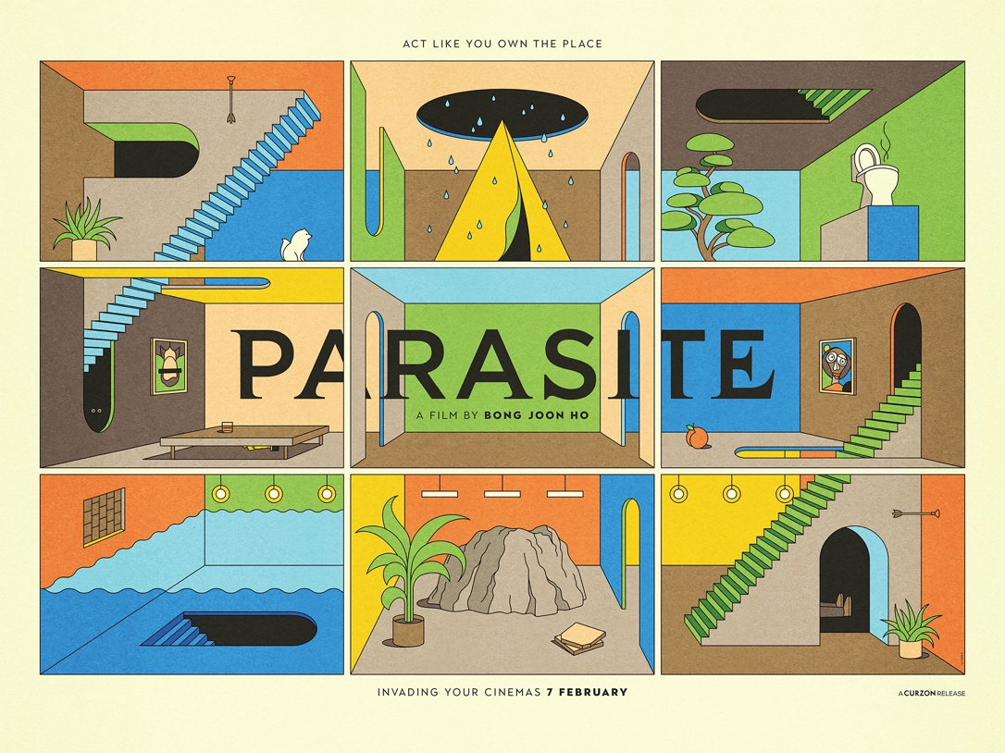

As the release approaches fresh content will be added to the google drive by Curzon Artificial Eye specifically aimed at reaching younger audiences so keep checking back to the file. Things like the Jessica Jingle the popularity of which is explained in the youtube video is already available as part of the UK assets.

Be sure to also follow the film’s official social media channels as well:

Twitter
@ArtificialEye
@parasitemovie

Instagram
Parasitemovie
ArtificialEyeFilm

As Curzon will be posting more content there and particularly content that links to the young cast in the film like this. The key message here is that the young characters/cast are primary protagonists in the film, and not secondary to the older characters/cast.

Curzon is also working with gaming streaming platform Twitch to create ‘reaction videos’ with gaming streamers watching the trailer and talking about their expectation and excitement which can be shared and are proving popular.

Hashtags:
#parasite (official)
#actlikeyouowntheplace (official UK)
#bonghive
#BongJoonHo
#parasitemovie
#koreancinema
#asianstyle

Korean links:

- Korean Cultural Centre UK
- Korean Film Council

Parasite: Additional campaign and marketing ideas

- Price: If you have a young person/student ticket offer, why not promote it alongside Parasite
- Experience: As suggested by the feedback from the FAN Young Consultants, research into audiences highlights how important the whole experience is. Think about inviting guest speakers to introduce or run post-screening discussions. Think about your food offer – are you able to add a Korean special to your menu for the run of the film or link to a local Korean restaurant? Nothing Korean nearby? The family spends time folding pizza boxes so that could be a fun link…
- Interaction/social media: Whilst inequality is a huge theme of the film which the Young Consultants are keen to highlight to their peers as something they’re passionate about, don’t forget to use the above assets to emphasise the humorous aspects of the film.

