Night of the Kings (15)

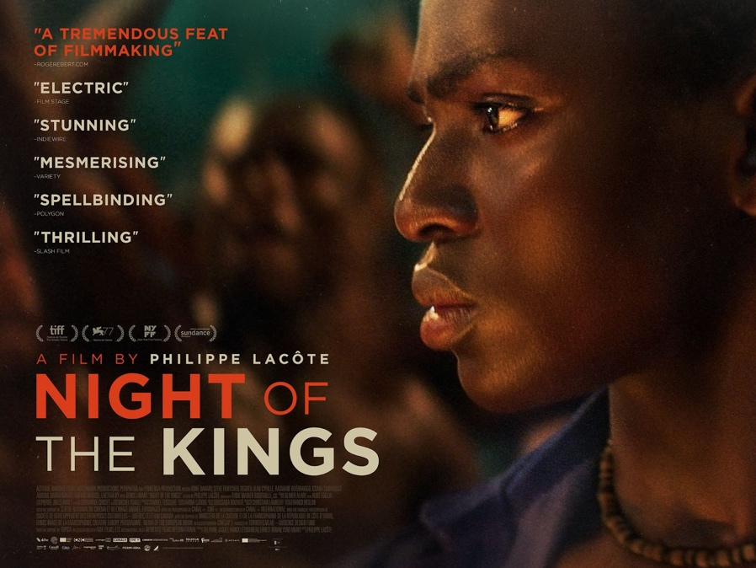

As Recommended by the FAN Young Consultants

Dir. Philippe Lacôte |Ivory Coast|2021|93 mins
French language with English subtitles

Starring: Steve Tientcheu, Issaka Sawadogo
Distributor: Altitude
Bookings: Bryony Forde bryonyforde@altitudefilment.com and Remi Hinds remihinds@altitudefilment.com
Available: 23 July 2021
Platform: Theatrical & PVOD

Synopsis
Spectacular, thrilling and absolutely unique, Night of the Kings is both an exhilarating tale of survival in one of the world’s most dangerous prisons and a beautiful ode to the power of storytelling.

When a young man is sent to an infamous prison, located in the middle of the Ivorian forest and ruled by its inmates, he is chosen to take part in a storytelling ritual just as a violent battle for control bubbles to the surface. After discovering the grim fate that awaits him at the end of the night, Roman begins to narrate the mystical life of a legendary outlaw to make his story last until dawn and give himself any chance of survival.

Social

Official website: Night Of The Kings | Altitude Films
Official Twitter: @AltitudeFilms
Official Facebook: @altitudefilmdistribution
Official Instagram: @altitudefilmuk
Official hashtag: #Nightofthekings

Press

The Guardian (20.07.21)
4* Review by Steve Rose
https://www.theguardian.com/film/2021/jul/20/night-of-the-kings-review-prison-drama-ivory-coast

Radio Times (02.07.21)
5* Review by Steve Morrissey
https://www.radiotimes.com/film/nvmft5/night-of-the-kings/

Little White Lies (21.07.21)
4* Review by Fred Onyango
https://lwlies.com/reviews/night-of-the-kings/

Assets

- Quad: https://bit.ly/NOTK-Quad
- 1 Sheet: https://bit.ly/NOTK-1S
- Trailer (16x9, Coming Soon): https://bit.ly/NOTK-Trailer-ComingSoon
- Trailer (1x1, Coming Soon): https://bit.ly/NOTK-Trailer1x1-ComingSoon
- Stories: https://bit.ly/NOTK-Stories
- 30” Spot (1x1): https://bit.ly/NOTK-30-1x1
- Trailer (YouTube): https://youtu.be/tr4ABLWYY8o
- Stills: https://bit.ly/NOTK-Stills

BBFC Guidance
Scenes of sexual threat, bloody images

FAN Young Consultants Feedback

The FAN Young Consultants group is a 10 strong group of under 30 year olds working in Film Exhibition across the UK. Working with Film Hub London’s Young Audiences Manager Moira McVean, the group is recommending new release films that they believe will resonate particularly well with their peers and young people aged 16-30.
Previous titles supported by the group include Parasite, Portrait of a Lady on Fire, The Assistant, Days of the Bagnold Summer, Babyteeth, Socrates, Rocks, County Lines, Mogul Mowgli, Willy’s Wonderland, Sound of Metal, Last Man Standing. Packs can be downloaded here

Thea Berry “I'm a big fan of magical realism, so I was already converted. At times the narrative was a little muddled and hard to follow, however I liked this. It was very compelling and a refreshing take on the 'prison drama' that, while it follows some of the usual tropes of toppling the king pin and struggles for power, does something original and authentic. Exciting to have something from the canon of post-colonial francophone cinema that will actually make it into cinemas.”
Louise Giadom “I went into the movie basically blind not knowing what to expect as I couldn’t tell much from the trailer. It was a really great surprise to see that storytelling was at the core of the film and that it had such strong fantastical elements. It was also really interesting because it’s a survival movie wrapped up in a fairy-tale story essentially. It was a little difficult to follow in that it was talking about things specific to their culture/history, but I read a review which explained the political message it had which made it make sense and actually made it even more interesting when you look at the way the story is told. I really enjoyed it, it was like a mishmash of theatre and film in one and I think it’ll be great to see a foreign language, full Black cast film like this be distributed in the UK, especially with how unique it is to the typical Black films we get.”
Caroline Wilson “Night of The Kings for me was a great example of modern mythical filmmaking. The story of Roman and the political issues in Ivory Coast were cleverly intertwined. The lighting, cinematography, casting and costume enhanced the story with the clever use of theatrical one location scenes for Roman's monologues. The interesting juxtapositions really challenged me as a viewer. The last 30 minutes of widening the story and linking it to the society I also found very interesting. The use of dance and movement was very new for me and a welcome change. It was a very challenging film that pushed boundaries from an auteur director.”

The Phoenix, Exeter has a newly formed Young Audience Panel of 18-25 year olds. Member Tina Valentine shares her thoughts on the film:

"Night of the Kings is a well-structured magical realist film - set almost entirely in a prison run by its inhabitants, the story is often fable-like in tone and morality, and has strengths across the ensemble cast and visuals. The acting and plot are complex and layered, providing responsive performances-within-performances as the central character spins a tale of imagined histories in an intense effort to protect his own future."

Jinwoo Lee had this to say about it:
“Night of the Kings is wonderfully unapologetic about the complex lore and mythology that pervades the prison. We, along with Roman, are absolutely thrown into the deep-end without any explanation as to what is supposed to be happening, and that’s the beauty of it all. It subverts today’s obsession with plot resolution in the most self-assured of ways, which is always appreciated.

Comparison/Complementary titles

- Mati Diop’s Atlantics
- Djibril Diop Mabéty’s Touki Bouki & Hyenas
- Blitz Bazawule’s The Burial of Kojo
- Souleymane Sissé’s Yeelen
- Fernando Meirelle’s City of God
- Jean-Stéphane Sauvaire’s A Prayer Before Dawn
- Benh Zeitlin’s Beasts of the Southern Wild

Themes
Storytelling, oral histories, rivalry, powerplay, violence, magical realism, folklore, dance & movement, political history

Recommended age
The group thought the film had interest for all ages 15+ with a sweet spot of 19-25.

Marketing ideas

- Can you do a ticketing offer? Pay what you can model? 2 for 1 or group discount for bookings? Indigo’s recent audience sentiment study highlighted that more than ever young people crave social experiences and reassurance that the experience will be value for money.
- There is a recorded Q&A available with director Philippe Lacôte – contact Altitude for more information.
- Think about which platforms you’re using to communicate with your audiences – the cinematography of the film is absolutely stunning as are the images available for use. Instagram is the perfect platform.
- Do you have links with your local secondary schools? French A’ level students would be a great audience for this film.
- Could you programme a season with the titles highlighted above (and also referenced in Sula Douglas Folkes Magical Realism in African Cinema article below? The themes the film highlights could spin you in multiple directions and the film really lends itself to interpretation. As Thea Berry references in her thoughts on the film ‘this is a great opportunity to highlight such an amazing part of film history.’ It’s also an opportunity to ‘talk about how films from this part of the world are not widely distributed and available to watch in Western cinemas.’
- The magic within the film is heightened by the use of dance and movement – this could be a new audience demographic for you to reach out to. Are you aware of young Theatre/dance/performative arts groups in your area that you could promote the film to or perhaps invite to perform before or after the screening?
- Could you create a mini exhibition in the foyer of the film’s artwork?
- Take inspiration from the work that We Are Parable is presenting with their tour of the film as part of their ‘Who We Are’ programme. They’re bringing together local artists to perform live poetry, music and dance at each of their screenings.

Recent audience data research conducted by Google suggests that more than ever, young people are interested in researching the background of the content they’re watching and as alluded to by Young Consultant Louise Giadom in her review above, this film warrants and deserves reading around. Here are some great articles to point audiences (and yourself) to:

Interesting Articles/Videos/contacts:

- Sula Douglas Folkes – Magical Realism in African Cinema – We Are Parable
- Variety Review – Peter Debruge
- Screendaily interview with Philippe Lacôte
- Background to the unrest in the Ivory Coast in 2011 that inspired Philippe Lacôte to make the film - Socialist Worker

