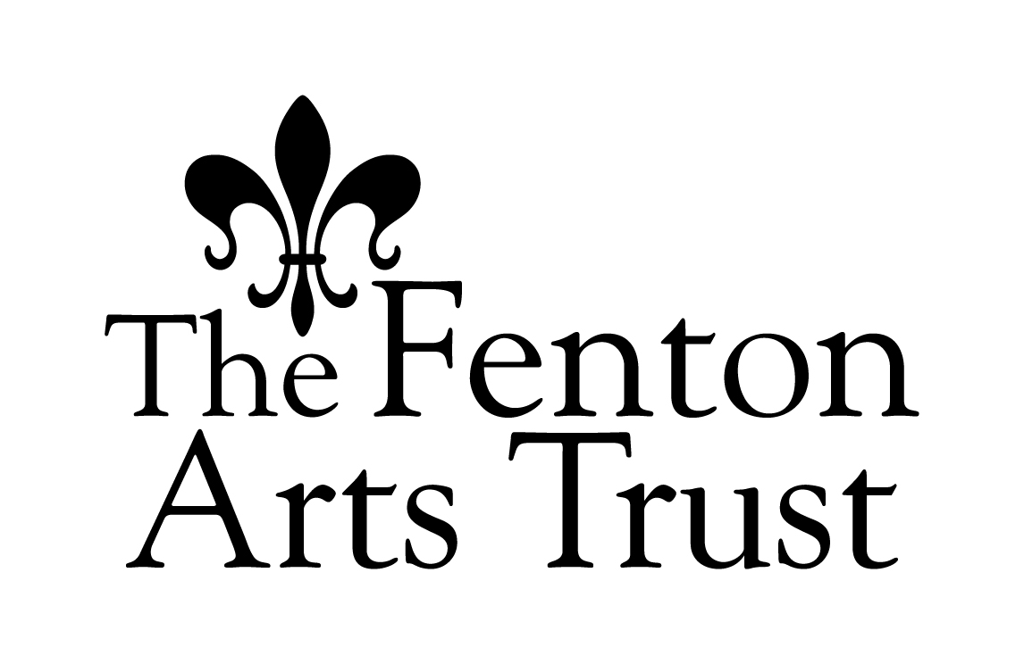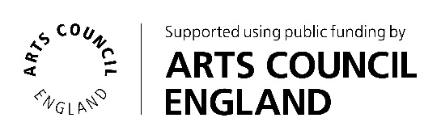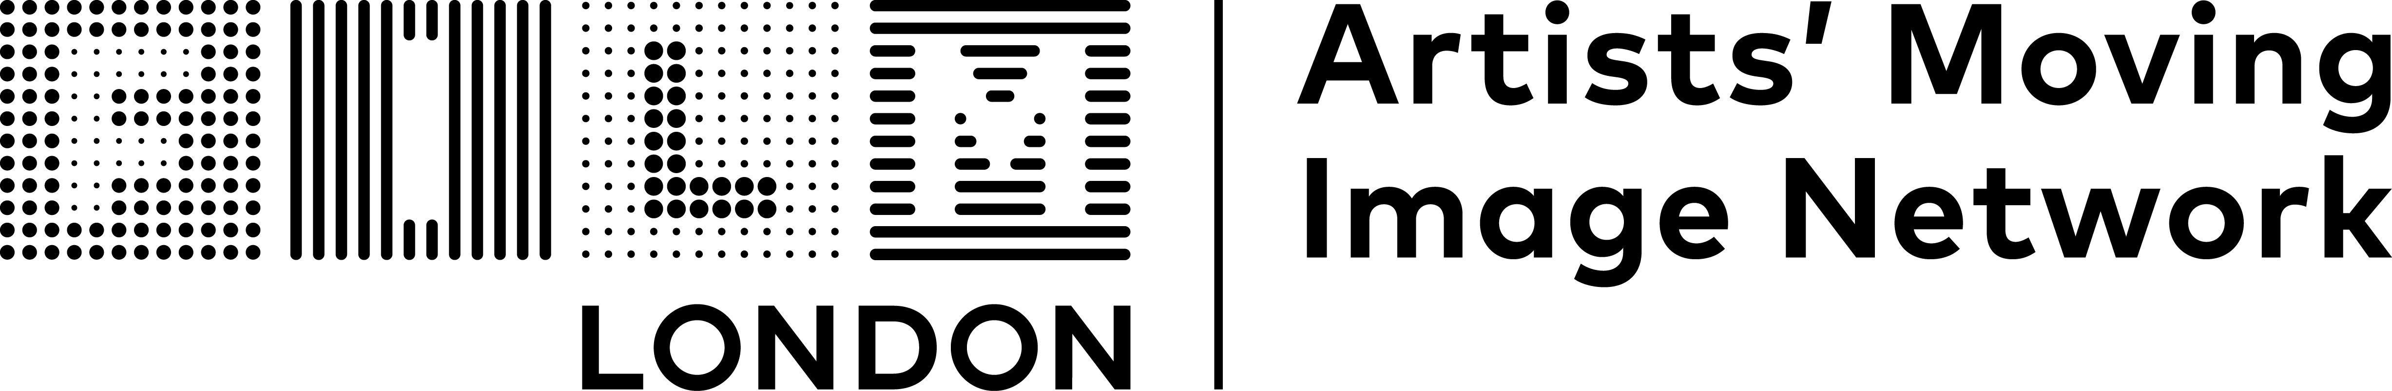

**The FLAMIN Fellowship   
Guidelines**

**Introduction**

Film London and Arts Council England present the FLAMIN Fellowship, a major development and commissioning scheme for England’s early career artist filmmakers.

The Fellowship aims to support **six** **early career artists** with exciting, innovative and challenging moving image practices.

FLAMIN aims to support these artists through a nine-month programme of workshops and bespoke production advice.

**The Fellowship**

The programme will focus on the specific challenges for artists working with the moving image. It will offer:

* A programme of professional practice workshops taking place in-person in London (travel costs from other parts of England can be covered)
* Development support sessions with Pinky Ghundale, an experienced Production Advisor
* Development bursary of £2,500 towards a specific project
* Specialist one-to-one advice sessions with an external expert
* Promotion through representation in screening programmes and online profile
* The benefits of being embedded in a peer group of moving image artists
* Profile and promotion through Film London’s newsletter and social media channels as FLAMIN alumni, during and after the artists’ time on the Fellowship

The workshops will take place once a month (please see key dates below). These sessions will cover key areas around sustaining artistic practice, with a focus on the moving image, including development and production planning, writing, budgeting, festival and exhibition strategy, working with museums and commercial galleries, copyright and intellectual property, and archiving your work.

FLAMIN connects with curators, festivals and programmers to seek potential screening and exhibition opportunities for artists on the FLAMIN Fellowship. After the Fellowship programme, we continue to support alumni in their careers and promote their work.

**Who can apply**

The FLAMIN Fellowship is set up to develop the practices of **early-career moving image artists based in England**.   
  
The Fellowship is open to:

* Artists with experience in working with moving image (at least two previous works that have been shown in exhibitions or screenings)
* Applicants who have had a professional artistic practice (outside of higher education) for at least two years, but for no more than five years. (Applicants do not need to have engaged in higher education to be eligible for the programme)
* Artists with a moving image project at an early stage that they would like to focus on developing during the programme
* Artists who are able to fully commit to the development scheme (see key dates below)

We can’t support:

* Artists taking part in another development programme (see list in FAQ’s document) or in receipt of a development award (e.g. Arts Council England Developing Your Creative Practice (DYCP) Award) during the Fellowship programme
* Artists who are represented by a commercial gallery
* Artists who have already had a solo show in a major publicly funded art space
* Artists enrolled on a full or part-time course of study at any level (Foundation, BA, MA or PhD) at any point during the Fellowship period
* Film-makers wishing to develop film industry careers – the Fellowship is for artists using moving image as their medium and engaging with the art world
* Artists based outside of England

**Selection process**

Selection for this opportunity will be through a two-stage process:

* Stage 1: A **short online application** from which up to 20 artists will be selected
* Stage 2: Up to 20 artists will be invited to submit a **more detailed application** that will include an idea for a project to develop, and will be invited to attend an interview. They will each be given a fee of £100. Interview questions will be shared in advance.

The FLAMIN Team will review all Stage 1 applications and watch all submitted work. They will then meet to select 20 artists to invite to submit projects at Stage 2.

Stage 2 applications will be read by the FLAMIN Team and Production Advisor Pinky Ghundale. Interviews will be with two members of the FLAMIN Team and the Production Advisor.

**Selection Criteria**

In Stage 1, we are looking for:

* Applications that demonstrate a strong, boundary pushing and innovative artistic practice
* Artists with experience in making moving image work, while still standing to benefit from the Fellowship support to develop a new work
* Artists at an appropriate stage of their careers, with some experience and success in engaging with the art world, who would still benefit from the content of the workshops

In Stage 2, we are looking for:

* Innovative and challenging moving image project ideas that show strong artistic vision
* Projects that are at an early stage of development
* Projects that are a logical and ambitious next step and an important new project for the applicant

**Feedback and Advice Sessions**

Last year we received 139 applications. This included many artists with interesting and innovative practices that we were unfortunately unable to support due to the limited number of places available.

The FLAMIN Team are committed to offering feedback and advice to unsuccessful applicants. Artists can request feedback calls following the assessment of their application after Stage 1 or Stage 2.

**Accessibility**

The FLAMIN Team are committed to accommodating artists with different access needs and providing support where required. Applicants selected for Stage 2 may submit a short video or audio recording outlining the project they would like to develop instead of a written project description.

Further access support is available from the FLAMIN Team upon request (contact details below).

**Key dates**

* May–June 2024 - Pre-application advice available to all artists
* Monday 17 June 2024 (12:00 midday) - Open call deadline
* Wednesday 17 July 2024 - Artists are notified of whether they are invited to submit for Stage 2
* Wednesday 07 August 2024 - Submission deadline for Stage 2 proposals
* Weeks starting 12 and 19 August 2024 - Selection Interviews
* 16 September to 31 October 2024 - Feedback and advice available on request to all unsuccessful applicants

**Fellowship programme dates:**

Wednesday 11 September - Workshop #1 and induction

Wednesday 02 October - Workshop #2

Wednesday 23 October - Workshop #3

Thursday 24 October - Production Advisor sessions #1

Wednesday 04 December - Workshop #4

Thursday 05 December - Production Advisor sessions #2

Wednesday 11 December - Artist Presentations

Wednesday 22 January - Workshop #5

Thursday 23 January - Production Advisor sessions #3

Wednesday 19 February - Workshop #6

Thursday 27 February - Production Advisor sessions #4

Wednesday 26 March - Workshop #7

Thursday 27 March - Production Advisor sessions #5

Wednesday 23 April - Workshop #8

Thursday 24 April - Production Advisor sessions #6

Wednesday 21 May - Workshop #9

**Contact details**

FLAMIN  
Film London

The Arts Building

Morris Place

London

N4 3JG

Tel: 020 7613 7676

Email: flamin@filmlondon.org.uk

[www.filmlondon.org.uk/flamin](http://www.filmlondon.org.uk/flamin)

**The FLAMIN team:**

Maggie Ellis, Head of Artists’ Moving Image

Rose Cupit, Senior FLAMIN Manager

Duncan Poulton, Programme Coordinator

Nathan Geyer, Programme Coordinator  
Pinky Ghundale, Production Advisor