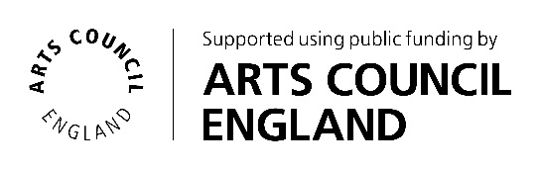
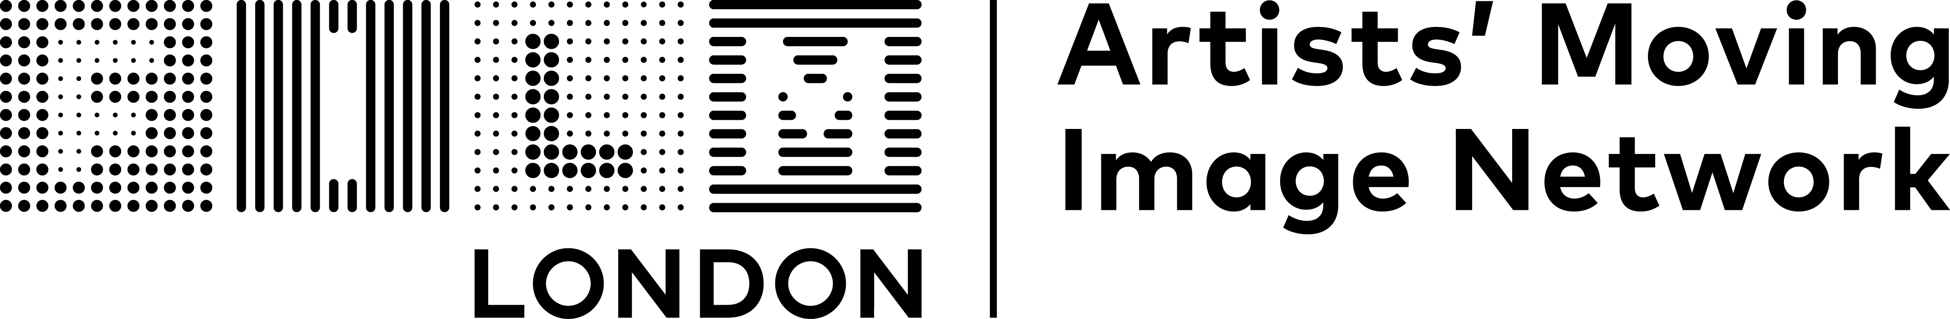

The FLAMIN Fellowship
Guidelines

Introduction

Film London and Arts Council England present the FLAMIN Fellowship, a major development and commissioning scheme for England’s early career artist filmmakers.

The Fellowship aims to support six early career artists with exciting, innovative and challenging moving image practices.

FLAMIN aims to support these artists through a nine-month programme of workshops and bespoke production advice.

The Fellowship

The programme will focus on the specific challenges for artists working with the moving image. It will offer:

- A programme of professional practice workshops taking place in-person in London (travel costs from other parts of England can be covered)
- Development support sessions with Pinky Ghundale, an experienced Production Advisor
- Development bursary of £2,500 towards a specific project
- Promotion through representation in screening programmes and online profile
- The benefits of being embedded in a peer group of moving image artists
- Profile and promotion through Film London’s newsletter and social media channels as FLAMIN alumni, during and after the artists’ time on the Fellowship

The workshops will take place once a month (please see key dates below). These sessions will cover key areas around sustaining artistic practice, with a focus on the moving image, including development and production planning, writing, budgeting, festival and exhibition strategy, working with museums and commercial galleries, copyright and intellectual property, and archiving your work. They will also provide opportunity for peer discussion and feedback on individual projects.

FLAMIN connects with curators, festivals and programmers to seek potential screening and exhibition opportunities for artists on the FLAMIN Fellowship. After the Fellowship programme, we continue to support alumni in their careers and promote their work.

Who can apply

The FLAMIN Fellowship is set up to develop the practices of early-career moving image artists based in England.
The Fellowship is open to:
- Artists with experience in working with moving image (at least two previous works that have been shown in exhibitions or screenings)
- Applicants who have had a professional artistic practice* (outside of higher education) for at least two years, but for no more than five years**. Applicants do not need to have engaged in higher education to be eligible for the programme
- Artists with a moving image project at an early stage that they would like to focus on developing during the programme
- Artists who are able to fully commit to the development scheme (see key dates below)

We can’t support:
- Artists taking part in another development programme (see list in FAQ’s document) or in receipt of a development award (e.g. Arts Council England Developing Your Creative Practice [DYCP] award) during the Fellowship programme
- Artists who are represented by a commercial gallery
- Artists who have already had a solo show in a major publicly funded art space
- Artists enrolled on a full or part-time course of study at any level (Foundation, BA, MA or PhD) at any point during the Fellowship period
- Film-makers wishing to develop film industry careers – the Fellowship is for artists using moving image as their medium and engaging with the art world
- Artists based outside of England

*Here we consider a ‘professional artistic practice’ to be making and exhibiting artwork to a public audience.

**If applicants have technically been practicing professionally as an artist for over 5 years, but feel that they are still in the early stages of their career and can make an argument for why this is the case (e.g. caring responsibilities), then their application will be considered at FLAMIN’s discretion. If this is your situation, we recommend phoning or emailing the FLAMIN team in advance of applying to enquire as to your eligibility.

Selection process

Selection for this opportunity will be through a two-stage process:
- Stage 1: A short online application from which up to 12 artists will be selected
- Stage 2: Up to 12 artists will be invited to submit a more detailed application that will include an idea for a project to develop, and will be invited to attend an interview. They will each be given a fee of £100. Interview questions will be shared in advance.
The FLAMIN Team will review all Stage 1 applications and watch all submitted work. They will then meet to select 12 artists to invite to submit projects at Stage 2.
Stage 2 applications will be read by the FLAMIN Team and Production Advisor Pinky Ghundale.

Selection Criteria

In Stage 1, we are looking for:
- Applications that demonstrate a strong, boundary pushing and innovative artistic practice
- Artists with experience in making moving image work, while still standing to benefit from the support of the Fellowship to develop a new work
- Artists at an appropriate stage of their careers, with some experience and success in engaging with the art world, who would still benefit from the content of the workshops
- A clear project idea that is feasible to develop during the Fellowship period and demonstrates a creative engagement with the moving image
In Stage 2, we are looking for:
- Innovative and challenging moving image project ideas that show strong artistic vision
- Projects that are at an early stage of development
- Projects that are an important new development in the applicant’s practice, and an ambitious next step in their career

Feedback and Advice Sessions

Last year we received 123 applications. This included many artists with interesting and innovative practices that we were unfortunately unable to support due to the limited number of places available.
The FLAMIN Team are committed to offering feedback and advice to unsuccessful applicants. Artists can request feedback calls following the assessment of their application after Stage 1 or Stage 2.

Key dates
- April – June 2026 - Pre-application advice available to all artists
- Monday 1 June 2026 (midnight) - Open call deadline

- Friday 24 July 2026 - Artists invited to submit for Stage 2

- Wednesday 12 August 2026 (midnight) - Submission deadline for Stage 2 proposals

- 19–27 August 2026 - Selection Interviews

- August – October 2026 - Feedback and advice available on request to all unsuccessful applicants
FLAMIN Fellowship programme dates

Artists need to be able to fully commit to the development scheme (see key workshop and production advice dates). All workshops and production advisor sessions are mandatory:

- Workshops are held in-person in London and last a full day
- Production advisor sessions are approximately one-hour calls, usually done online.
- Artist Presentation crit sessions are an informal chance to share progress on your projects. They happen in-person in London and last a full day

- Thursday 17th September 2026 - Introduction Session

- Thursday 1st October 2026 - Workshop #1
- Wednesday 28th October 2026 - Production Advisor sessions #1

- Thursday 29th October 2026 - Workshop #2

- Friday 27th November 2026 - Production Advisor sessions #2

- Thursday 3rd December 2026 - Workshop #3

- Thursday 10th December 2026 - Artist Presentations crit session
- Wednesday 20th January 2027 – Production Advisor sessions #3

- Thursday 21st January 2027 - Workshop #4
- Wednesday 24th February 2027 - Production Advisor sessions #4

- Thursday 25th February 2027 - Workshop #5
- Wednesday 17th March 2027 - Production Advisor sessions #5

- Thursday 18th March 2027 - Workshop #6

- Thursday 15th April 2027 - Artist Presentations crit session

- Thursday 22nd April 2027 - Workshop #7

- Wednesday 12th May 2027 - Production Advisor sessions #6

- Thursday 20 May 2027 – Workshop #8

Accessibility

We are happy to provide support and discuss accessibility requirements with applicants who may identify as having a disability. These could include:
- Our staff providing help, guidance and support with putting together an application
- Staff helping you identifying a support worker to assist you with the application
- A contribution of up to £200 towards a fee for your known Access Support Worker to help you make an application
- Please first email or phone us to have a conversation about the best option for you.
If you would like to submit your application in an alternative format (e.g. audio or video recordings), or if you have any questions about the application process or the FLAMIN Fellowship programme, please contact the FLAMIN team.

Contact details

FLAMIN
Film London
The Arts Building
Morris Place
London
N4 3JG
Tel: 020 7613 7676

Email: flamin@filmlondon.org.uk
www.filmlondon.org.uk/flamin

The FLAMIN team:
Rose Cupit, Head of Artists’ Moving Image
Duncan Poulton, Programme Coordinator
Nathan Geyer, Programme Coordinator
Maggie Ellis, FLAMIN Production Executive
Jamie Wyld, FLAMIN Programme and Development Associate
Pinky Ghundale, Production Advisor

