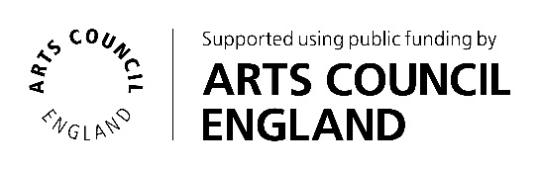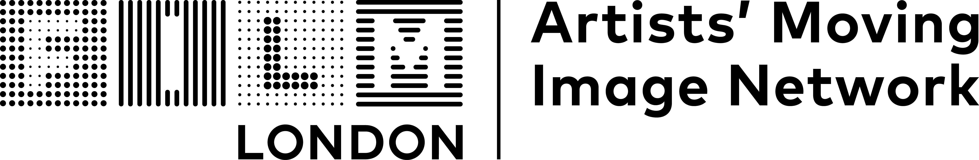

**The FLAMIN Fellowship**

**Guidelines**

**Introduction**

Film London and Arts Council England present the FLAMIN Fellowship, a major development and commissioning scheme for England’s early career artist filmmakers.

The Fellowship aims to support **six** **early career artists** with exciting, innovative and challenging moving image practices.

FLAMIN aims to support these artists through a nine-month programme of workshops and bespoke production advice.

**The Fellowship**

The programme will focus on the specific challenges for artists working with the moving image. It will offer:

* A programme of professional practice workshops taking place in-person in London (travel costs from other parts of England can be covered)
* Development support sessions with Pinky Ghundale, an experienced Production Advisor
* Development bursary of £2,500 towards a specific project
* Promotion through representation in screening programmes and online profile
* The benefits of being embedded in a peer group of moving image artists
* Profile and promotion through Film London’s newsletter and social media channels as FLAMIN alumni, during and after the artists’ time on the Fellowship

The workshops will take place once a month (please see key dates below). These sessions will cover key areas around sustaining artistic practice, with a focus on the moving image, including development and production planning, writing, budgeting, festival and exhibition strategy, working with museums and commercial galleries, copyright and intellectual property, and archiving your work. They will also provide opportunity for peer discussion and feedback on individual projects.

FLAMIN connects with curators, festivals and programmers to seek potential screening and exhibition opportunities for artists on the FLAMIN Fellowship. After the Fellowship programme, we continue to support alumni in their careers and promote their work.

**Who can apply**

The FLAMIN Fellowship is set up to develop the practices of **early-career moving image artists based in England**.   
  
The Fellowship is open to:

* Artists with experience in working with moving image (at least two previous works that have been shown in exhibitions or screenings)
* Applicants who have had a professional artistic practice* (outside of higher education) for at least two years, but for no more than five years**. Applicants do not need to have engaged in higher education to be eligible for the programme
* Artists with a moving image project at an early stage that they would like to focus on developing during the programme
* Artists who are able to fully commit to the development scheme (see key dates below)

We can’t support:

* Artists taking part in another development programme (see list in FAQ’s document) or in receipt of a development award (e.g. Arts Council England Developing Your Creative Practice [DYCP] award) during the Fellowship programme
* Artists who are represented by a commercial gallery
* Artists who have already had a solo show in a major publicly funded art space
* Artists enrolled on a full or part-time course of study at any level (Foundation, BA, MA or PhD) at any point during the Fellowship period
* Film-makers wishing to develop film industry careers – the Fellowship is for artists using moving image as their medium and engaging with the art world
* Artists based outside of England

*Here we consider a ‘professional artistic practice’ to be making and exhibiting artwork to a public audience.

**If applicants have technically been practicing professionally as an artist for over 5 years, but feel that they are still in the early stages of their career and can make an argument for why this is the case (e.g. caring responsibilities), then their application will be considered at FLAMIN’s discretion. If this is your situation, we recommend phoning or emailing the FLAMIN team in advance of applying to enquire as to your eligibility.

**Selection process**

Selection for this opportunity will be through a two-stage process:

* Stage 1: A **short online application** from which up to 12 artists will be selected
* Stage 2: Up to 12 artists will be invited to submit a **more detailed application** that will include an idea for a project to develop, and will be invited to attend an interview. They will each be given a fee of £100. Interview questions will be shared in advance.

The FLAMIN Team will review all Stage 1 applications and watch all submitted work. They will then meet to select 12 artists to invite to submit projects at Stage 2.

Stage 2 applications will be read by the FLAMIN Team and Production Advisor Pinky Ghundale.

**Selection Criteria**

In Stage 1, we are looking for:

* Applications that demonstrate a strong, boundary pushing and innovative artistic practice
* Artists with experience in making moving image work, while still standing to benefit from the support of the Fellowship to develop a new work
* Artists at an appropriate stage of their careers, with some experience and success in engaging with the art world, who would still benefit from the content of the workshops
* A clear project idea that is feasible to develop during the Fellowship period and demonstrates a creative engagement with the moving image

In Stage 2, we are looking for:

* Innovative and challenging moving image project ideas that show strong artistic vision
* Projects that are at an early stage of development
* Projects that are an important new development in the applicant’s practice, and an ambitious next step in their career

**Feedback and Advice Sessions**

Last year we received 162 applications. This included many artists with interesting and innovative practices that we were unfortunately unable to support due to the limited number of places available.

The FLAMIN Team are committed to offering feedback and advice to unsuccessful applicants. Artists can request feedback calls following the assessment of their application after Stage 1 or Stage 2.

**Accessibility**

If you need the application materials in an alternative format (for example, large print or as audio), or if you have any access requirements for completing and submitting this application please contact the FLAMIN team on 020 7613 7676, flamin@filmlondon.org.uk.

**Key dates**

* April – June 2025 - Pre-application advice available to all artists
* Monday 2 June 2025 (12:00 midday) - Open call deadline
* Monday 28 July 2025 - Artists invited to submit for Stage 2
* Monday 11 August 2025 (12:00 midday) - Submission deadline for Stage 2 proposals
* Week commencing Monday 18 August 2025 - Selection Interviews
* 25 August – 13 October 2025 - Feedback and advice available on request to all unsuccessful applicants

**FLAMIN Fellowship programme dates**

Artists need to be able to fully commit to the development scheme (see key workshop and production advice dates). All workshops and production advisor sessions are mandatory:

* Workshops are held in-person in London and last a full day
* Production advisor sessions are approximately one-hour calls, usually done online.
* Wednesday 17 September 2025 - Introduction Session
* Wednesday 1st October 2025 - Workshop #1
* Wednesday 29th October 2025 - Workshop #2
* Thursday 30th October 2025 - Production Advisor sessions #1
* Thursday 27th November 2025 - Production Advisor sessions #2
* Wednesday 3rd December 2025 - Workshop #3
* Wednesday 10th December 2025 - Artist Presentations
* Wednesday 21st January 2026 - Workshop #4
* Thursday 22nd January 2026 – Production Advisor sessions #3
* Wednesday 25th February 2026 - Workshop #5
* Thursday 26th February 2026 - Production Advisor sessions #4
* Wednesday 25th March 2026 - Workshop #6
* Thursday 26th March 2026 - Production Advisor sessions #5
* Wednesday 15th April 2026 - Artist Presentations
* Wednesday 22nd April 2026 - Workshop #7
* Thursday 23rd April 2026 - Production Advisor sessions #6
* Wednesday 20 May 2026 - Workshop #8

**Contact details**

FLAMIN  
Film London

The Arts Building

Morris Place

London

N4 3JG

Tel: 020 7613 7676

Email: flamin@filmlondon.org.uk

[www.filmlondon.org.uk/flamin](http://www.filmlondon.org.uk/flamin)

**The FLAMIN team:**

Maggie Ellis, Head of Artists’ Moving Image

Rose Cupit, Senior FLAMIN Manager

Duncan Poulton, Programme Coordinator

Nathan Geyer, Programme Coordinator  
Pinky Ghundale, Production Advisor