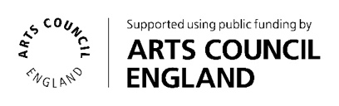
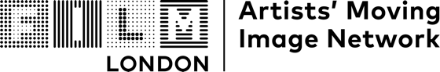

The FLAMIN Fellowship 2026-27
Pre-fill Application Form
Please find below an offline ‘pre-fill’ version of the FLAMIN Fellowship application form, in order to see the questions and to prepare your submission. Submissions need to be made using the Wufoo online application form at the following link:
Online form:
https://flamin.wufoo.com/forms/the-flamin-fellowship-2026-application-form/
Stage 1 Application form
(12 artists will be longlisted)
Deadline: Monday 1 June 2026 (midnight)
- Name
- Address
- Email
- Phone
- Website/social media link

- Describe your practice (up to 200 words)
Please provide details about the form your art practice takes, how it is shown and any themes or concerns your work addresses. If you are applying as a collaborative duo, please make this clear in this section.
- Describe the project you would like to develop (up to 200 words)
Describe what the proposed work is about (e.g. subject, story, themes and ideas). If possible, describe the form the work is likely to take and how the project will be approached in terms of style, look and technique - your visual approach. It would be useful to provide information on the stage the project is at.

- Artist CV (no more than 2 pages, PDF or Word document)

- Eligibility information (optional - 100 words)
If you would like to provide any extra information about your eligibility, please include this here.
Supporting Materials
Please include two previous moving image works.
Works should be uploaded to a file hosting site such as Vimeo and supplied to us as URL links. Links can be password protected if necessary, if so please provide passwords. Please send full-length works rather than excerpts or showreels. All videos must be kept available to view online throughout the duration of the assessment process (until end of August 2026).
Please include the following information about each previous work:
- Title, Date, Duration
- Link to view work (with password, if applicable)
- Optional short description/synopsis of work (max 50 words per work)

Stage 2 Application form
(longlisted artists paid £100 each to prepare a proposal and attend an interview)
Deadline: Wednesday 12 August 2026 (midnight)

- Project working title

- Expected duration and format (e.g. single screen, multichannel installation, VR etc)

- Project description (max 500 words)

- Optional reference images/research as PDF (4 pages max)

