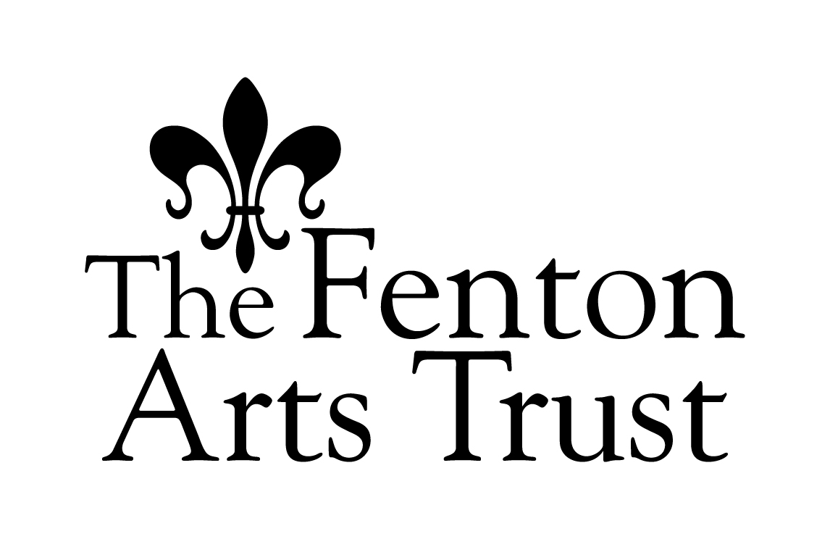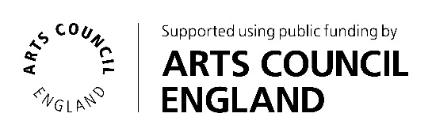

The FLAMIN Fellowship   
Frequently Asked Questions

# Can I get feedback on my application before I apply? The FLAMIN team can provide general advice on a project and the preparation of an application, or elaborate on any information given in the Guidelines and FAQs. You can also email the FLAMIN team with any questions at [flamin@filmlondon.org.uk](mailto:flamin@filmlondon.org.uk). Unfortunately, due to time constraints, FLAMIN is not able to read and feedback on draft applications before they are submitted.

# What do you mean by moving image practice? You must be an artist with a track record of working with the moving image. Your work must have been shown in an art world context (e.g. exhibitions, film festivals etc.). Any approach to the moving image is welcomed, this includes, but is not limited to, multi-channel work, installation, Virtual Reality (VR), Augmented Reality (AR) and online-based work. We are looking for artists who are committed to experimenting with the moving image medium, though their practice might also include working in other media.

1. **What is the time commitment required from Fellows?**Artists need to be able to fully commit to the development scheme (see key workshop and production advice dates). All workshops and production advisor sessions are mandatory. Workshops are held in-person in London and last a full day, production advisor sessions are approximately one-hour calls, usually done online. Fellows are also expected to independently work on their project ideas and research, in dialogue and regular contact with the FLAMIN team.
2. **What do you mean by ‘professional artistic practice’?**  
     
   Here we consider a ‘professional artistic practice’ to be making and exhibiting artwork to a public audience.
3. **Do I need to have a qualification, e.g. a degree, to be eligible?**  
     
   No, applicants do not need to have completed higher education or further education qualifications to be eligible for the programme.
4. **What if I have had to take breaks from practicing as an artist, does the two to five year criteria still apply?**  
   If applicants have technically been practicing professionally as an artist for over 5 years, but feel that they are still in the early stages of their career and can make an argument for why this is the case (e.g. having needed to take time out due to carer responsibilities), then their application will be considered at FLAMIN’s discretion. If this is your situation, we recommend phoning or emailing the FLAMIN team in advance of applying to enquire regarding your eligibility.  
     
   See some examples of eligible applicants below (this list is not exhaustive):  
   - ‘I graduated from a Bachelors course (BA) in a fine art/moving image related subject between 2 and 5 years ago and have been pursuing my art practice since graduating.’  
   - ‘I began my professional art practice over 5 years ago, but had to take a break from it due to carer responsibilities. Because of this I still consider myself to be an early-career artist.’  
   - ‘I just completed a fine art/moving image related Masters course (MA) but have had a professional practice for at least two years before this period of study.’  
   - ‘I have no fine art qualification but have made and shown work for up to 5 years.’
5. **What do you consider to be a solo show in a major space?**  
   The Fellowship aims to support artists who have not yet had significant exposure and opportunities. If you have been part of an exhibition that focused solely on your work, in a publicly funded gallery, you may not be eligible. If you are unsure, we recommend you enquire with the FLAMIN team in advance of applying.
6. **I am due to participate in a development programme during the period of the FLAMIN Fellowship. Am I eligible to apply?**  
   No, we cannot support artists who are taking part in development programmes already, even if these overlap with only part of the FLAMIN programme (e.g. funded development periods like Arts Council England’s Developing Your Creative Practice awards, or structured development programmes).  
     
   There are a number of artist development programmes including but not limited to:  
   ActionSpace, AltMFA, City Lit (Fine Art and Developing Art Practice Courses), The Collective Studio, Conditions, Constellations, Essential School of Painting, EBC Schools, Evening Class @ Mayday Rooms, Feral Art School, Freelands Artist Programme, Heatherleys, Into the Wild, Intoart, Islington Mill Academy, MYOM, Newlyn Art School, Open School East, Royal Academy Schools, Royal Drawing School, School for Civic Imagination, School of Speculation, School of the Damned, The Syllabus, TOMA, Turps Art School, UNION: The Northern School for Creativity & Activism and Warehouse Alternative Art School.  
     
   Taking part in another development programme at the same time as The FLAMIN Fellowship would give an applicant less time to focus. We also aim to support artists who have had less access to development support and so would benefit more from the Fellowship.
7. **I work between different locations in and outside of England – am I eligible?**   
     
   We appreciate that working as an artist means you may live in one place and work in others. To qualify as England-based you should have a correspondence address with an England postcode, and spend the majority of your time working on projects in England at the time of making your application.
8. **I don’t live in London. Can FLAMIN help with my travel costs to attend the workshops?**  
     
   FLAMIN has a small budget that can be allocated towards travel costs for non-London based participants. This will be discussed and arranged on a case-by-case basis.
9. **Is there a bias, weighting or quota involved in the decision making of applicant’s location? Are artists who live outside of London more likely to be selected?**  
     
   There is no bias, weighting or quota involved in relation to where applicants live. Selection will take place on the basis of the Selection Criteria outlined in the Guidelines.
10. **I work collaboratively with another artist. Do you accept applications from duos?**  
      
    Yes, we do accept applications from collaborative duos for The FLAMIN Fellowship. When applying as a collaborative duo, one of the artists must be named as the ‘lead’ contact. Please make it clear that you are applying as a collaboration in the ‘Describe your practice’ question. (In the case that a collaborative group is selected for Round 2 of the application, the £100 fee will be shared between the applicants.)
11. **Who will be speaking at the workshops and available as mentors?**  
      
    The speakers and mentors will be confirmed once the selection of artists has taken place, in order to respond to the needs of the participants and ensure that the content is bespoke to the group and as relevant as possible. In past editions of the programme, we have had speakers from organisations including: ACME Studios, a-n, Arts Council England, Artquest, Auguste Orts, Berwick Film & Media Arts Festival, BFI, British Council, CPH:DOX, DACS, Film and Video Umbrella, Forma, Jerwood Arts, Julia Stoschek Collection, LUX, not/nowhere, Nottingham Contemporary, Somerset House Studios, South London Gallery, Tate, Thomas Dane Gallery, Vdrome and the Wellcome Trust. In addition, FLAMIN invites a range of industry specialists including artists’ film producers, facilities houses, production designers, archivists, sound designers, distribution and exhibition specialists, curators and gallerists. Practicing artists who have lead FLAMIN Fellowship workshops in the past include: Larry Achiampong, Graeme Arnfield, Jasmina Cibic, Billy Dosanjh, Onyeka Igwe, Esther Johnson, Rachel Maclean, Daria Martin, Noor Afshan Mirza & Brad Butler, Hetain Patel, Imran Perretta, Heather Phillipson, Marianna Simnett and Michelle Williams Gamaker.
12. **What will working with the Production Advisor involve?**  
      
    Throughout the year, each selected artist will receive one-to-one advice sessions with Production Advisor Pinky Ghundale. These will take place approximately monthly (see key dates), either in-person or online, and will each take about one hour with some follow up correspondence by email. The advice will focus on how to progress your project, including establishing a budget, planning a timeline, advice on direction, research and suggested contacts.
13. **What does the external specialist advice involve?**   
      
    In addition to the Production Advisor support, during the course of the programme each artist will be allocated an advice session with an external advisor with expertise that is relevant to their chosen project. The advisor will be selected in discussion with the FLAMIN Team and Production Advisor.
14. **What is the rationale behind the two-stage application process?**

FLAMIN has sought to reduce the amount of unpaid labour and time committed by artists applying to The FLAMIN Fellowship with a newly simplified two-stage application process. Applications to Stage 1 will provide an overview of artists’ existing moving image practice to date, and will be assessed for their eligibility and suitability for the development programme. Applicants selected for Stage 2 will be invited to submit a project proposal and attend an interview, and be given a fee of £100 in acknowledgement of the work involved in this submission.

Tender, a research project led by Artquest into artist open calls, was informative in the development of this application process. Read more about Tender, [here](https://artquest.org.uk/research/tender-2/).

1. **If I am invited to submit a Stage Two application, what does my project description need to include? Are there any restrictions on types of projects?**  
     
   Describe what the proposed work is about (e.g. subject, story, themes and ideas). If possible, describe the form the work is likely to take and how the project will be approached in terms of style, look and technique - your visual approach. It would be useful to provide information on what stage the project is at currently. It is understood that many projects might need further development and research before the shape of the work becomes clear. It is also understood that details may change or emerge as the project develops. There are no restrictions on where the projects can be researched or filmed.
2. **What can the development bursary be used for?**  
     
   FLAMIN will support artists with £2,500 towards developing the project that they would like to focus on as part of the programme. The funding can be used purely for development costs. It can also be used as seed funding in order to realise additional finance for a project, or to fully fund a new artwork after the development process is complete. Costs can include experimenting with new filmic approaches for the project; research time/artists’ fee; sourcing material; conducting interviews, etc.
3. **If I am awarded a Fellowship how soon will I get the money?**  
     
   The bursary will be released in two tranches, the first will be issued when you agree to take part in the Fellowship, and the second upon completion of the development programme. We expect Fellows to present a report on their participation for evaluation purposes.
4. **Will I be expected to realise a completed piece of work as a result of the Fellowship?**  
   There is no requirement to have completed a finished film by the end of the Fellowship.
5. **Why do you ask for the completion of an Equal Opportunities Form?**  
   The form is for monitoring purposes only and will not be taken into consideration by the assessors. All data is compiled anonymously and we review it to establish whether we are reaching and supporting a broad range of people through our schemes. An Equal Opportunities monitoring form must also be received to comply with our funders’ regulations. You must complete the Equal Opportunities Monitoring Form as part of your online application in order for it to be eligible.
6. **Will FLAMIN solicit applications?**  
     
   FLAMIN may invite applications from specific applicants to help achieve its aims and objectives. These applications will be assessed in the same way as any other and are not guaranteed funding.
7. **What accessibility resources are available?**  
     
   We are happy to assist artists who may identify as having a disability and are interested in participating in The FLAMIN Fellowship. Please contact the FLAMIN team if you would like to discuss your accessibility requirements, or require assistance with the application process.  
     
   We are open to discussing any access needs at any stage of the process – application, development and production – and are committed to finding ways to enable filmmakers to realise their project if selected for the Fellowship. Examples of accessibility assistance we could offer will be dependent on the needs of applicants, but might include providing a note taker, live captioning on video calls, transcription etc.
8. **If my application is unsuccessful, can I appeal the decision?**   
     
   Applicants can only appeal against a decision if they believe the procedures for application and assessment outlined in the Guidelines and FAQs were not adhered to. Applications will be judged and may be turned down on feasibility, creative merit or on other subjective grounds, such as the extent of the project’s ability to fulfil the fund’s remit against which there is no appeal. Feedback is available for all unsuccessful applications.
9. **Will there be another round, can I apply again?**  
     
   New rounds of The FLAMIN Fellowship will be announced on the [FLAMIN newsletter](https://filmlondon.org.uk/mailing-list) and [social media channels](https://twitter.com/FL_FLAMIN).
10. **I still have questions**  
    Please email us at [flamin@filmlondon.org.uk](mailto:flamin@filmlondon.org.uk) or call on +44 (0) 20 7613 7676