DAYS OF THE BAGNOLD SUMMER
As recommended by the FAN Young Consultants
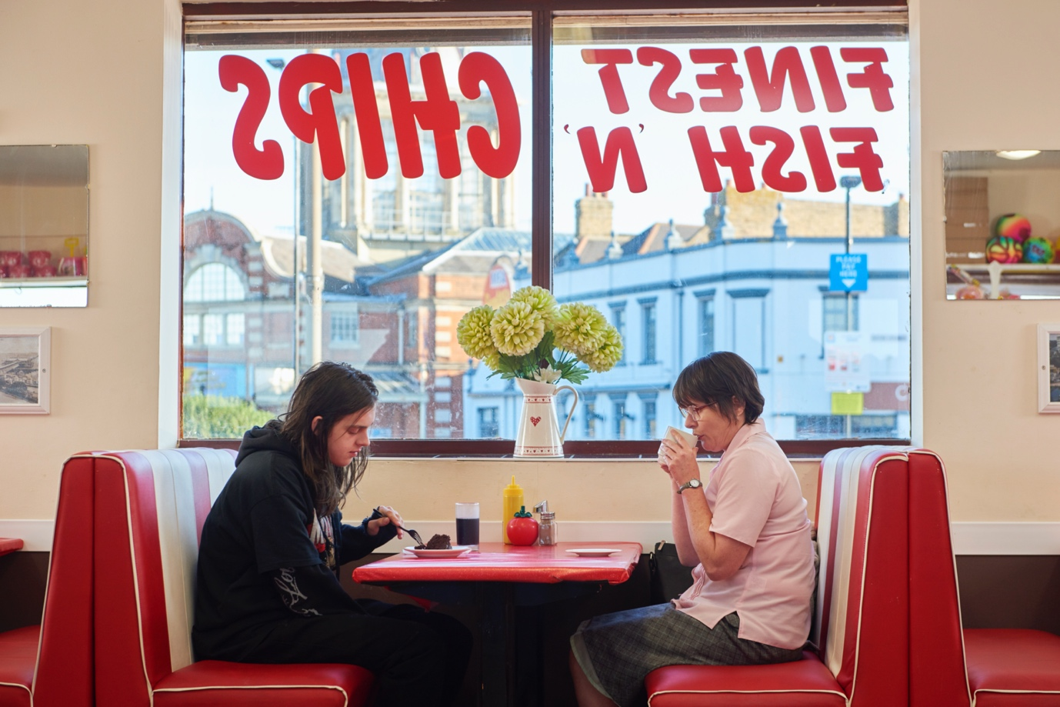
Specification details:
Days of the Bagnold Summer
Dir. Simon Bird|86 mins|UK|2019
Distributor: Altitude
Contact: Bryonyforde@altitudefilment.com
Available: From Monday 8th June
Platforms: iTunes, Amazon, Google Play, Sky Store, Virgin, BT, Curzon Home Cinema, and BFI Player
Key cast:
Director: Simon Bird (Directorial Debut, best known for his roles in The Inbetweeners & Friday Night Dinner)
Writers: Lisa Owens (Screenplay) and Joff Winterhart (Graphic Novel)
Featuring: Monica Dolan; Earl Cave; Tamsin Greig; Rob Brydon; Alice Lowe

Official Synopsis:
Sue (52), works in a library. Daniel (15), eats crisps and listens to Metallica. This was the summer Daniel was due to spend with his father and his father’s new wife in Florida. But when they cancel his trip at the last minute, Sue and Daniel suddenly face the prospect of six long weeks together.

Over the course of one long summer, an epic war of wills rages in the unassuming battleground of their suburban home as Sue and Daniel reckon with private tragedies – and pursue their personal passions.

Based on Joff Winterhart’s award-winning graphic novel, this is a beautifully observed, universal coming-of-age story capturing all the tension, pathos and affection of family life.

Live Q&As
Director Simon Bird, Earl Cave, and Monica Dolan will be taking part in all of the Q&As.
And screenwriter Lisa Owens will be joining the Curzon Q&A on Friday as well.

- Monday 8th June, the Digital Premiere, in partnership with Yahoo Movies UK, hosted by Edith Bowman at 8.30pm
- Wednesday 10th June in partnership with the BFI at 7pm hosted by Ali Plump
- Friday 12th June in partnership with Curzon Home Cinema, hosted by Robbie Collin at 8.30pm

FAN Young Consultants feedback
The FAN Young Consultants are a 21 strong group of under 30 year olds working in Film Exhibition across the UK. Working with Film Hub London’s Young Audiences lead Moira McVean, moira.mcvean@filmlondon.org.uk the group is recommending new release films that they believe will resonate particularly well with their peers and young people aged 16-30.
Previous titles supported by the group include Parasite, Portrait of a Lady on Fire, The Assistant & White Riot. Packs can be downloaded here

“I thought the two lead performances were good, as was their chemistry. Days is at its best when Daniel and Sue are on screen together - it effectively captures the sort of sullen fecklessness teenagers are capable of and the hurt that can cause the people around them. Sidenote: Daniel’s hair is so on point greasy that I was torn between recoiling in horror and an urge to reach through the screen and give it a good wash.”
“I thought it was a simple and sweet coming of age film…I really enjoyed it…I thought the relationship between Daniel and his mother was believable and relatable as I could sympathise with what he was going through.”
“I liked how the Mum was really strong (despite costumed appearances). Because the location was like white-label suburbia I felt it made it relatable in terms of geography to anyone. Therefore, it was easier to project a bit more of yourself and your teenage experience into the film… it captured the rollercoaster and ridiculousness that being a teenager is. Some of the lines made me laugh out loud. It was just kind of soothing to be reminded of how difficult being a teenager can be, and then to be reminded of how many sacrifices parents make for their kids.”
“I really enjoyed it. It was sweet and quirky. It kind of reminded me of a cross between Driving Lessons and Ghost World. I loved that it was being a cute off-beat British film and wasn't trying to do too much. I liked the performances between Daniel and Sue.”
“I really enjoyed this film - it isn't ground-breaking, but it isn't trying to be. I found it an entertaining, easy watch with funny moments and relatable characters. In uncertain times, the familiar domesticity was a welcome contrast to the some of the high-drama and dystopian features I have seen recently. I'd recommend it - it won't change your life, but it'll make you smile.”
Key Themes
Youth culture
Music (Metallica/Heavy Metal/Belle & Sebastian!)
Familial relationships
Divorce & dating after divorce
Summer holidays
Boredom
Coming of age

Suggested target audience: 25+ or families

Marketing ideas

- Focus promotion of the film to your audiences on the subject matter using the Hashtags below, and the key themes highlighted above.
- Promote the online Q&As taking place as a hook to encourage your audience to watch the film (see details above)
- Try a live ‘watch-a-long’ – set a specific time for everyone to watch together and then use social media to chat together as you’re watching.
- Could you create your own online panel with film industry professionals/local bands from your area?
- Target Simon Bird fans particularly & celebrate the weirdness! – could you do a shoe giveaway?! Or a comic book/graphic novel/ art celebration or giveaway?
- Celebrate the nothingness of the summer and all the time we’ve spent in lockdown so far
Funding support for FAN members:
BFI FAN has created ‘Film Feels Connected’, a season designed to spotlight innovation, promote online activities and help you to try out new things.
- Apply for a grant of up to £1,500 to help you put on an event, here.
- From technical streaming support, to marketing advice – find guides and resources on running events, here
Official UK Digital Assets:
The following can all be found here:

- Trailer
- Stills
- Poster
- Social media

Social Media:
Twitter
@AltitudeFilms
@lamowens
@bellesglasgow

Instagram
@AltitudeFilmUK
@Bellesglasgow

Facebook
@altitudefilmdistribution

Hashtags
- #DaysOfTheBagnoldSummer
- #earlcave
- #Simonbird
Press Quotes:
- Laugh-out-loud funny with a big heart... Terrific" - Mark Kermode, MK3D
- "An utter delight from start to finish... A charming British gem" - HeyUGuys
- "A love letter to single mums, introverts, and the great British summer" - Sight and Sound
- "Outstanding" - Film Stories
- "Heartfelt and hilarious" - The Upcoming
Interesting articles/video

- MK3D – Mark Kermode talking to Simon Bird and Monica Dolan
- Guardian review
- Simon Bird interview
- Joff Winterhart’s graphic novel review – Guardian

Tips on how to set up and run online Film-Clubs

- Cinema for All has created this guide
- And Saffron Screen has shared their experience of switching to an online film club format here and have produced this case study here
- More on The Bigger Picture here about moving online

