Blue Jean (15)

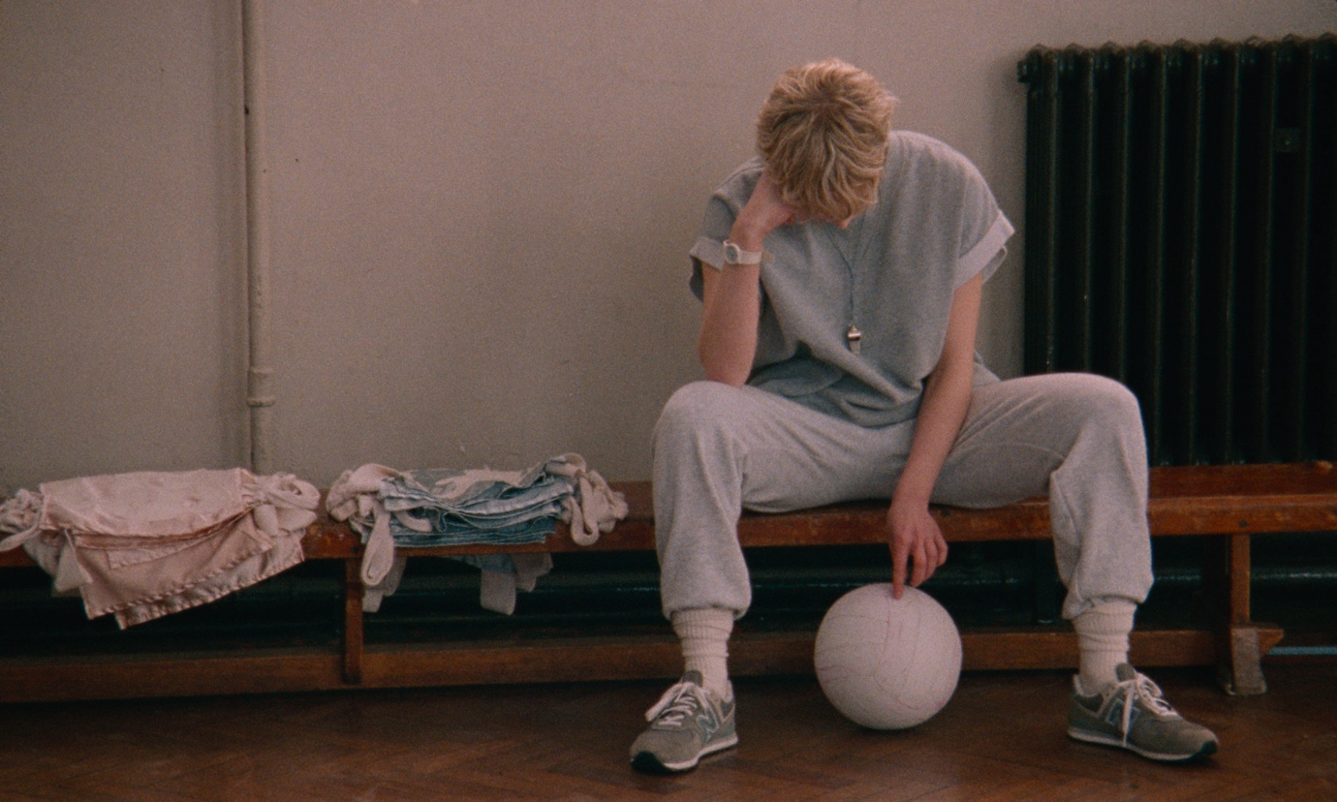

As Recommended by the FAN Young Consultants

Dir. Georgia Oakley | UK |2022 | 1hr 37mins

Distributor: Altitude
Bookings: bryonyforde@altitudefilment.com
Available: Friday 10th February 2023
Platform: Theatrical
Cast: Rosy McEwen (National Theatre’s Othello, The Alienist), Kerrie Hayes (Black Mirror), Lucy Halliday, Lydia Page
Language: English
DCP available with AD/HOH

BBFC strong language, sex, sex references, homophobia

Synopsis
England, 1988 – Margaret Thatcher’s Conservative government are about to pass a law stigmatising gays and lesbians, forcing Jean, a PE teacher, to live a double life. As pressure mounts from all sides, the arrival of a new girl at school catalyses a crisis that will challenge Jean to her core.

Production Notes available HERE
AWARDS
Nominee - BAFTA - Outstanding Debut by a British Writer, Director, or Producer
Winner - BIFA, Best Lead Performance (Rosy McEwen)
Winner - BIFA, Best Supporting Performance (Kerrie Hayes)
Winner - BIFA, Debut Screenwriter (Georgia Oakley)
Winner - BIFA, Best Casting (Shaheen Baig)
Winner - Audience Award - Giornate Degli Autori, Venice Film Festival
Winner - Breakthrough Performance (Rosy McEwen, Kerrie Hayes) - Belfast Film Festival
Nominated - Sutherland Award (First Feature Competition) - BFI London Film Festival

Social

Official website: https://www.altitude.film/home
Official Twitter: @AltitudeFilms
Official Facebook: @AltitudeFilmDistribution
Official Instagram: @AltitudeFilmUK
Hashtags: #BlueJean #LGBTHM23 #LGBTplusHM

Social handles: @Ge0r91a ; @chrisroemusic

Press

Quotes
"A slam-dunk masterpiece" ★★★★★ - THE TELEGRAPH

"A knockout performance from Rosy McEwen" - SCREEN DAILY

"Deeply human" ★★★★★ - ATTITUDE MAGAZINE

“A quietly searing British debut” - VARIETY

“A vital film in the current British climate” - ALTERNATIVE LENS

“Rosy McEwen puts in a calling card performance for the ages” - THE PLAYLIST

“A film teeming with compassion and nuance” - THE UPCOMING

“Timeless… Georgia Oakley’s outstanding debut is a must-watch” ★★★★★ - LOUD AND CLEAR

“Poignant and impactful” - LITTLE WHITE LIES

“Rosy McEwen is phenomenal” ★★★★★ - ONE ROOM WITH A VIEW

"An essential watch that serves up a poignant look at LGBTQIA history" - DIVA

★★★★ - ROLLING STONE

“McEwen…is bound for stardom”
★★★★ - TOTAL FILM

Assets

1 Sheet: Download
Quad: Download
Stills: Download

Trailer (mp4 1x1, 16x9, 9x16): Download
Trailer (YouTube): https://www.youtube.com/watch?v=mGGRNmIU7fc

Social Assets: Download
30” Spot: Download

FAN Young Consultants Feedback
The FAN Young Consultants group is a 10 strong group of under 30 year olds working in Film Exhibition across the UK. Working with Film Hub London’s Young Audiences Manager Moira McVean, the group is recommending new release films that they believe will resonate particularly well with their peers and young people aged 16-30.
Previous titles supported by the group include Parasite, Portrait of a Lady on Fire, The Assistant, Days of the Bagnold Summer, Babyteeth, Socrates, Rocks, County Lines, Mogul Mowgli, Willy’s Wonderland, Sound of Metal, Last Man Standing, Night of the Kings, Limbo, Souad, Gagarine You Will Die at Twenty, Petite Maman, Bad Luck Banging: or Loony Porn, Boiling Point, Belle, Flee, Ali & Ava, Happening, The Worst Person in the World, All My Friends Hate Me, Pleasure, The Feast, Queen of Glory, Off the Rails, Triangle of Sadness, Neptune Frost, All the Beauty and the Bloodshed. Packs can be downloaded here

James Calver
If it wasn’t for Aftersun I’d say this was the best British Film of last year. It’s very good within its own right but as a debut feature it becomes even better, as there is a level of nuance in the way that Georgia Oakley orchestrates the interactions between her characters which I find very rare in the works of some of the most experienced directors. The big thing for me though was the way in which it subconsciously drew similarities between the setting of the film politically (Thatcher’s Britain) to today’s perspectives on the lives of LGBTQ+ people. Also, final point - this film is gorgeous to look at. There’s a blend of this 80s aesthetic with some modern techniques to make a gorgeous looking film.

Alex Goldsmith
Evoking emotions felt by the LGBT+ community at the time, Blue Jean tells the story of a lesbian P.E. teacher forced to live a double life during a rise of homophobia in the wake of Section 28. Director Georgia Oakley brilliantly captures the bleakness of 1980's Britain in a time of significant struggle with this stunningly shot feature that passes off convincingly as a film made of the time. Oakley navigates sorrow and rage with a well balanced and surprisingly tender script that examines loneliness, guilt, and self-discovery, observing the impact the oppression of Thatcher's ruling had on various individuals. -- Rosy McEwan is compelling in the lead performance of Jean, a woman robbed of her self-expression in a battle to keep her professional and personal lives in balance. Her relationships are strained as she attempts to bury her sexuality to save face in public and amongst her colleagues. This not only puts her in odds with the system but also with her partner (Kerrie Hayes) who has a different point-of-view in their struggle. The appearance of a new queer student at the school threatens to reveal Jean's identity, challenging her to choose between acting as an ally or as a foe. -- Brilliant and intimately observed, this debut drama makes Georgia Oakley another British talent to keep an eye on!

Feedback from students at the London College of Communications (BA Film & Screen Studies)
The students are part of the BA (Hons) Film and Screen Studies at London College of Communication, University of the Arts, London. They study the historical, theoretical, cultural, and critical analysis of film and screen, developing the next generation of filmmakers and influencers in the commissioning, distribution, curation and exhibition of film and screen.

“I really enjoyed the film It’s very beautiful, in terms of visuals and story.”

“The sound effect is excellent. Very simple story with good humour.”

“It was very interesting to see the Northeast gay scene in the 80s and how laws impacted institutions.”

“I thought the film was a truthful insight into a time which many experienced and many can’t imagine to experience. A stark contrast between the politics of sexuality that we experience today.”

“I really enjoyed it, I didn’t know much about this law beforehand, so I found it extremely insightful.”

“I found the film a very emotional and insightful exploration of the lesbian experience during the time period. The music, mise en scene and cinematography are all very aesthetically pleasing and fit the film’s story well.”

“I like the palette and set design of the film, it is all about blue. It's visually comfortable.”

Comparison/Complementary titles:
Portrait of a Lady on Fire/Celine Sciamma films, Bad luck Banging:Or Looney Porn, Joyland, Fishtank, Jellyfish, Imitation Game, Watermelon Woman, Blue is the Warmest Colour

Themes
Protest, discrimination, personal breakthrough, identity, acceptance, LGBTQ+, class, politics, ethics of power, homophobia

Recommended age
16-30 but sweet spot of 19-25

Marketing ideas
- Can you do a ticketing offer? Pay what you can model? 2 for 1 or group discount for up to 6?
- Think about which platforms you’re using to communicate with your audiences (Instagram and Twitter recommended for this title and target age group)
- Enhance the atmosphere of your cinema space by playing the Blue Jean Soundtrack or inspirational Spotify playlist listed below.
- FAN Young Consultant James Calver “there’s a lot to draw on here for the audience, mainly the LGBTQ+ characters, the Thatcherite politics and the nostalgia for the 80s, even though that tends to be an era most people nostalgic for it weren’t even born in.” Think about inviting a member of your local or regional Pride group to introduce the screening. You can locate Pride events here and subsequently find a contact for your local group.
- It was the campaign against Section 28 that led to the formation of Stonewall (see article listed below). Take a look at the Stonewall website that’s loaded with resources. The film is released during the LGBTQ+ History month (February) so in lieu of an external speaker, could a member of your staff introduce the screening, informed by the Stonewall resources?
- To tap into the ‘nostalgia’ James refers to above – could you host an ‘80’s night’ with themed clothes, food, drinks. Photobooths, or polaroid shots are always popular!
- Set up a post screening informal ‘wine & chat’ session
- Do you have a University local to you? Could you invite one of the history/politics/physical education lecturers to contextualise the screening?
- Consider inviting your local sixth form college for a schools screening. Into Film has advice and resources on how to work with schools and it’s all free to access.

You could also ehance the screening by screening a short before Blue Jean.
WOFFF22 and Iris Prize award-winning Looking for Barbara by Helen Kilbride (2021, 9 min) is available for screening via the WOFFF team for a small screening fee.

“A filmmaker’s personal archive in the form of Super 8 footage from the 1990s, the film explores the filmmakers queer personal history with the kind of "behind-the-scenes" treasures usually found in boxes in attics, garages and cupboards.

Helen is a Liverpool-based lesbian filmmaker and lecturer in media production, creative digital production and journalism.”

Women Over 50 Film Festival (WOFFF), now in its 9th year, celebrates older women in front of and behind the camera with an annual festival at Depot, in Lewes, and year-round films and events.

Outwith the festival, WOFFF is active in the community with Moving Pictures, a DVD of WOFFF shorts and creative activities, which connects older people - in residential care homes and in community venues – with film.

Interesting Articles/Videos/contacts:

- Podcast recommended by Director Georgia Oakley – The Cineskinny
- BLUE JEAN Soundtrack;
- https://open.spotify.com/playlist/59CELnTz867xEHwY36fE4u?si=e42ec28efd894155&nd=1
- BLUE JEAN Inspiration playlist;
- https://open.spotify.com/playlist/6O31gEJMAnL0KjvtovY0jn?si=6b1bdab6fae54f97
- Video interview with Director Georgia Oakley - Cineuropa
- Guardian interview with Rosy McEwen
- Globe Screen UK podcast with composer Chris Roe
- Interview with Director Georgia Oakley – The Skinny
- The end of Section 28, November 18, 2003 – Stonewall article

