All My Friends Hate Me (15)

As Recommended by the FAN Young Consultants

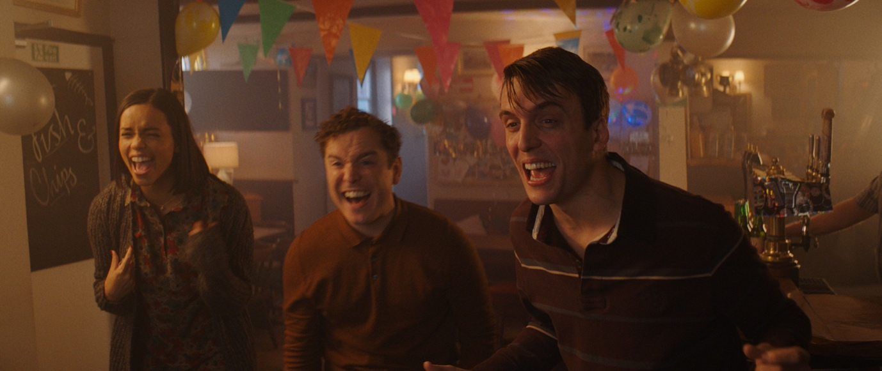

Dir. Andrew Gaynord|UK|2021| 94 mins

Distributor: BFI
Bookings: bookings.films@bfi.org.uk
DCP with HOH subtitles/Audio Description (AD)
Available: Friday 10th June
Platform: Theatrical
Cast: Tom Stourton, Georgina Campbell, Joshua McGuire, Antonia Clarke, CharlyClive, Dustin Demri-Burns, Graham Dickson, Kieran Hodgson and Christopher Fairbank.

BBFC guidance: very strong language, drug misuse, brief nudity

Short Synopsis

All My Friends Hate Me is a deliciously dark comedy about social paranoia.

Or

When Pete's old uni friends invite him for weekend away in the country to celebrate his birthday he finds their immature ways haven’t changed and he’s baffled by their spontaneous invitation to a feral stranger from the local pub to join them.

Long Synopsis

Pete (Tom Stourton) is ready to leave his youthful indulgences behind and settle down with his girlfriend, Sonia (Charly Clive). When his uni friends invite him for a country weekend away to celebrate his birthday he finds their immature ways haven’t changed and he’s baffled by their spontaneous invitation to a feral stranger from the local pub to join them. With the atmosphere turning from tense to terrifying to surreal, Pete reaches breaking point. Is he being punished? Is he being paranoid? Or is he just part of some sick joke? Directed by Andrew Gaynord from a razor sharp script by Tom Stourton and Tom Palmer, with a cast of rising British talent, All My Friends Hate Me is a deliciously dark comedy about social paranoia.

Social

Official website: https://www.allmyfriendshatemefilm.co.uk/
Official Twitter: @BFI
Official Facebook:@BritishFilmInstitute
Official Instagram: @amfhmfilm
Official hashtag: #AllMyFriendsHateMe

Listings website: www.allmyfriendshatemefilm.co.uk
To be listed email: marketing.films@bfi.org.uk

Press

★★★★
'Like being in a pressure cooker of social awkwardness’ TimeOut

★★★★
'Seriously entertaining...Genius' – Empire

★★★★
‘Painfully funny portrayal of social awkwardness, loaded with black humour’ -Metro

‘Dark, twisted, eerie...I loved it’ - James King, BBC Radio

‘Ferociously witty, wincingly accurate’–Jessica Kiang, Variety

‘Dark, sinister and very funny’ - Peter Sobczynski – RogerEbert.com

Assets
In the link above you’ll find:

- Clips
- Gifs
- Posters
- Stills
- Trailers
- Review cards
- Press reviews and quotes
- And more!

FAN Young Consultants Feedback
The FAN Young Consultants group is a 10 strong group of under 30 year olds working in Film Exhibition across the UK. Working with Film Hub London’s Young Audiences Manager Moira McVean, the group is recommending new release films that they believe will resonate particularly well with their peers and young people aged 16-30.
Previous titles supported by the group include Parasite, Portrait of a Lady on Fire, The Assistant, Days of the Bagnold Summer, Babyteeth, Socrates, Rocks, County Lines, Mogul Mowgli, Willy’s Wonderland, Sound of Metal, Last Man Standing, Night of the Kings, Limbo, Souad, Gagarine You Will Die at Twenty, Petite Maman, Bad Luck Banging: or Loony Porn, Boiling Point, Belle, Flee, Ali & Ava, The Worst Person in the World, Happening. Packs can be downloaded here

Louise
This was one of the most awkward and uncomfortable films to watch but in a good way - pretty sure they intended it to feel like that. You really feel how the main character feels. It's very unnerving and unsettling to watch, it's the kind of film you watch through your hands not because you're scared but because you're cringing and uncomfortable. I think for a lot of people this would be a struggle to sit through but if you get through it, it's enjoyable. I liked that you never really knew what was going on, even at the end when you think his girlfriend hates him, she's just joking so you're still left on a 'what the hell just happened' note. I think it really taps into the mindset of someone with anxiety/social awkwardness has in group settings or at parties and that makes the whole thing work really well. Also, there's probably a deeper meaning to be had from watching this but honestly, you're so caught up in how uncomfortable it all is that it doesn't really register - but it's definitely a film I'll always remember.

Colette
I found it an entertaining and anxiety inducing watch, and I remember that feeling now which is a good sign! In a way it works a bit like a B Movie horror where each of the characters is an archetype/caricature, and that is not always a bad thing by any means.

Thea
Thea - Excruciating but in a fun way! A sharp critique of classism in Britain and of how privileged Brits sense of guilt around bettering themselves and being perceived as better by their peers fills them with just crippling anxiety. We do self-loathing comedy v well and I laughed a lot while simultaneously feeling like I couldn't watch it any longer.
Alex
Offering an exaggerated yet authentic examination of insecurities through a group of young upper-class adults reuniting years after graduation, All My Friends Hate Me is a social anxiety comedy that fringes on existential horror. A bit like a Joanna Hogg film crossed with an episode of Black Mirror. The filmmakers here have cooked up something great but gut-wrenching here… we follow Pete, the nervous birthday boy, who continuously questions if his friends, who all offer a range of unlikable traits and revelations, are really on his side. The story unfolds in ways that keep you on your toes guessing, maximising moments of stress and making you dig deep into your own uncertainties. This film prayed on all of my anxieties and is a must watch for anyone who has ever felt awkward, out of place, and feeling like everybody hates them… so sit back and get uncomfortable.

Themes
Relationships, friendship, life stages/expectations, social anxiety, identity, social class, growing up

Recommended age
18+ sweet spot 25-30

Marketing ideas

- Can you do a ticketing offer? Pay what you can model? 2 for 1 or group discount for up to 6?
- Think about which platforms you’re using to communicate with your audiences (Instagram and Twitter recommended for this title and target age group)
- There are some really fun digital assets that help ramp up the comedy and social anxiety aspects of the film in the Assets section.
- Could you host a post-screening discussion about how social awkwardness is a trait in British comedies and dramas?
- Set up a post screening informal ‘wine & chat’ session
- Could you invite young writers in your area to review the film and put their spin on the story? Or perhaps to deliver an introduction on the ‘coming of age’ genre?

Interesting Articles:

- NY Times review: Skewering the Anxious Young Things
- LA Times review: The dark British comedy ‘All My Friends Hate Me’ is designed to make you squirm
- Letterboxd Interview: Bumble and Cringe: The Social Anxiety of Totally Tom’s All My Friends Hate Me
- BFI interview with Tom Stourton and Antonia Clarke
- BFI Interview with Director Andrew Gaynord

